

Astana IT University

Faculty of Information Technology

Software engineering Department

**“School management system using SQL server”**

*Prepared by:*

Abisheva Dayana

*Teacher:*Aidana Kalakova

Nur-Sultan,2020

1. Introduction

Recently, it has been found that about 45% of schools in Kazakhstan use the file system. Basically, all these schools are faced with many problems that lead to errors in the system. One of the problems is the inconvenient use of the system for teachers, administrators and the school principal. Therefore, the best solution for this situation is to create a database for the school. A database management system (DBMS) is a software package designed to define, manipulate, retrieve and manage data in a database. The old school file system can lead to file redundancy, but this is prevented in the database because there is one database and any change to it is immediately reflected. Because of this, there is no way to run into duplicate data. Thus, it is safe to say that the first benefit of a database system is the reduction of data redundancy. Also very important is the data exchange, which is also provided by the database. In a database, database users can exchange data with each other. Which is very convenient for all schools. In addition, the DBMS ensures absolute data integrity. Data integrity means that the data in the database is accurate and consistent

2.Methodology

The database for the school will become a comfortable environment for not only school staff, but also for students. Students can check their grades at any time and teachers can check student attendance and progress.

1. Aim

Create a practical and convenient system for getting information about students and their parents. It allows to access all student-related information with ease, thus facilitating the work of school administrators and teachers.

Student (M:1) class.

Student study in one class, class can has many students.

class (1:1) class teacher.

Class can has one class teachers, teacher can has one class.

Class (1:1) classroom.

Class can owns one classroom, classroom belongs to one class.

Teacher (1:1) course

A teacher can teach one course, a course is tough by one teacher.

Students (1:M) grades

Students can have many grades, grades can be given to one student.

Student (M:1) parent.

Student has parents, parents can have many students(children).

Attendance (M:1) students.

Attendance belongs to one students, student has many attendances.

Student(1:M) exam

Student can pass many exam, exams are passed by one student.

Grade(M:1) final grade

One final grade is output from several grades, several grades consist one final grade.

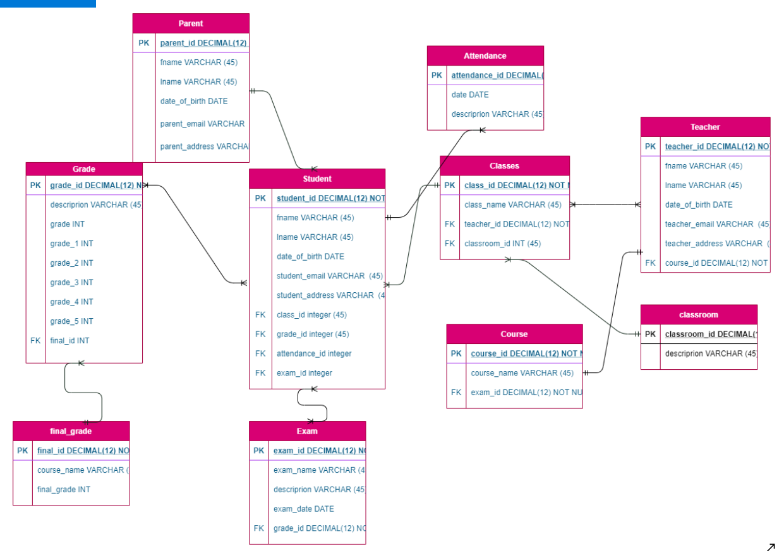

create table student (

student_id INT NOT NULL,

fname VARCHAR (45) NOT NULL,

lname VARCHAR (45) NOT NULL,

date_birth DATE NOT NULL,

student_email VARCHAR (45) NOT NULL,

student_address VARCHAR (45) NOT NULL,

parent_id INT REFERENCES parent(parent_id),

class_id INT REFERENCES classes(class_id),

attendance_id INT REFERENCES attendance(attendance_id),

exam_id INT REFERENCES exam(exam_id),

grade_id INT REFERENCES grade(grade_id),

primary key (student_id)

);



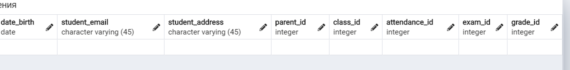

create table parent(

parent_id INT NOT NULL,

fname VARCHAR (45) NOT NULL,

lname VARCHAR (45) NOT NULL ,

date_birth DATE NOT NULL,

parent_email VARCHAR(45) NOT NULL,

parent_address VARCHAR (45) NOT NULL,

primary key (parent_id)

);

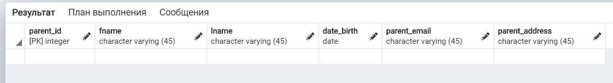

create table attendance(

attendance_id INT NOT NULL,

date DATE NOT NULL,

description VARCHAR(45) NOT NULL,

primary key (attendance_id)

);

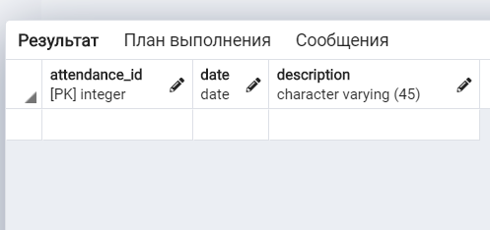

create table course(

course_id INT NOT NULL,

course_name VARCHAR (45) NOT NULL,

primary key (course_id)

);

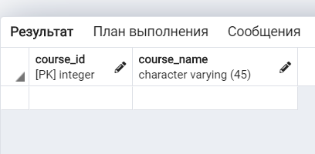

create table classroom(

classroom_id INT NOT NULL,

description VARCHAR (45) NOT NULL,

primary key (classroom_id)

);

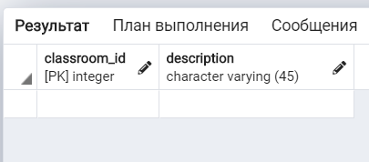

create table teacher(

teacher_id INT NOT NULL,

fname VARCHAR (45) NOT NULL,

lname VARCHAR (45) NOT NULL,

date_birth DATE NOT NULL,

teacher_email VARCHAR(45) NOT NULL,

teacher_address VARCHAR (45) NOT NULL,

primary key (teacher_id),

course_id INT REFERENCES course(course_id)

);



create table classes(

class_id INT NOT NULL,

class_name VARCHAR (45) NOT NULL,

primary key (class_id),

classroom_id INT REFERENCES classroom(classroom_id),

teacher_id INT REFERENCES teacher(teacher_id)

);

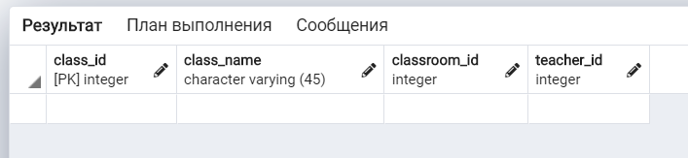

create table final_grade(

final_id INT NOT NULL,

course_name VARCHAR (45) NOT NULL,

final_grade INT NOT NULL,

primary key (final_id)

);

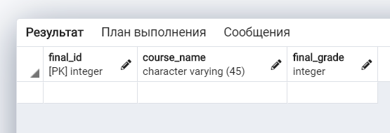

create table grade(

grade_id INT NOT NULL,

grade INT NOT NULL,

description VARCHAR (45) NOT NULL,

grade_1 INT NOT NULL,

grade_2 INT NOT NULL,

grade_3 INT NOT NULL,

grade_4 INT NOT NULL,

grade_5 INT NOT NULL,

primary key (grade_id),

final_id INT REFERENCES final_grade(final_id)

); 

create table exam(

exam_id INT NOT NULL,

exam_name VARCHAR (45) NOT NULL,

description VARCHAR(45) NOT NULL,

exam_date DATE NOT NULL,

exam_grade INT NOT NULL,

grade_id INT NOT NULL,

primary key (exam_id)

);

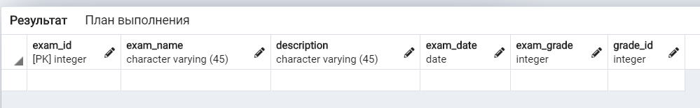

1. COURSE

insert into course (course_id, course_name) values (1001, 'geometry'), (1002, 'biology'), (1003, 'english'), (1004, 'chemistry'), (1005, 'physics'), (1006, 'geography'), (1007, 'history'), (1008, 'culturology'), (1009, 'literacy'), (1010, 'social study');

2) TEACHER

insert into teacher (teacher_id, fname, lname, date_birth, teacher_email, teacher_address, course_id) values (411, 'Alfi', 'Von Der Empten', '1987-09-25', 'avonderempten0@icq.com', '3244 Dawn Trail', 1001);

insert into teacher (teacher_id, fname, lname, date_birth, teacher_email, teacher_address, course_id) values (412, 'Desiri', 'Sketcher', '1994-03-06', 'dsketcher1@mayoclinic.com', '764 Schurz Park', 1002);

insert into teacher (teacher_id, fname, lname, date_birth, teacher_email, teacher_address, course_id) values (413, 'Juline', 'Kiellor', '1987-11-12', 'jkiellor2@telegraph.co.uk', '5983 Montana Trail', 1003);

insert into teacher (teacher_id, fname, lname, date_birth, teacher_email, teacher_address, course_id) values (414, 'Manon', 'Sarrell', '1977-06-21', 'msarrell3@theglobeandmail.com', '70972 Warner Point', 1004);

insert into teacher (teacher_id, fname, lname, date_birth, teacher_email, teacher_address, course_id) values (415, 'Carrie', 'Pocklington', '1981-07-31', 'cpocklington4@economist.com', '9939 Manufacturers Point', 1005);

insert into teacher (teacher_id, fname, lname, date_birth, teacher_email, teacher_address, course_id) values (416, 'Virgina', 'Dukesbury', '1984-08-14', 'vdukesbury0@meetup.com', '3 Dayton Plaza', 1006);

insert into teacher (teacher_id, fname, lname, date_birth, teacher_email, teacher_address, course_id) values (417, 'Arlena', 'Bontine', '1983-05-17', 'abontine1@pinterest.com', '532 Logan Way', 1007);

insert into teacher (teacher_id, fname, lname, date_birth, teacher_email, teacher_address, course_id) values (418, 'Sascha', 'Cushion', '1983-02-15', 'scushion2@nytimes.com', '38233 Thierer Parkway', 1008);

insert into teacher (teacher_id, fname, lname, date_birth, teacher_email, teacher_address, course_id) values (419, 'Loria', 'Werndley', '1992-08-10', 'lwerndley3@businessweek.com', '821 Schiller Trail', 1009);

insert into teacher (teacher_id, fname, lname, date_birth, teacher_email, teacher_address, course_id) values (420, 'Herculie', 'Trevance', '1992-07-27', 'htrevance4@technorati.com', '1 Ridgeview Pass', 1010);

3) CLASSES

insert into classes (class_id, class_name, classroom_id, teacher_id) values (901, '11a',511, 411), (902, '11b',512,412), (903, '11v',513,413), (904, '11g',514,414), (905, '11d',515,415), insert into classes (class_id, class_name, classroom_id, teacher_id) values (906, '10a',516, 416), (907, '10b',517,417), (908, '10v',518,418), (909, '10g',519,419), (910, '10d',520,420);

4) CLASSROOM

insert into classroom (classroom_id, description) values (511, 'geometry cabinet'), (512, 'biology cabinet '), (513, 'english cabinet'), (514, 'chemistry cabinet'), (515, 'physics cabinet'), insert into classroom (classroom_id, description) values (516, 'geography cabinet'), (517, 'history cabinet '), (518, 'culturology cabinet'), (519, 'literacy cabinet'), (520, 'social study cabinet');

5) EXAM

insert into exam (exam_id, exam_name, description, exam_date) values (701, 'geometry final exam', 'variant 1', '2020-11-25');

insert into exam (exam_id, exam_name, description, exam_date) values (702, 'algebra final exam', 'variant 1', '2020-11-23');

insert into exam (exam_id, exam_name, description, exam_date) values (703, 'biology final exam', 'variant 2', '2020-11-24');

insert into exam (exam_id, exam_name, description, exam_date) values (704, 'chemistry final exam', 'variant 2', '2020-11-23');

insert into exam (exam_id, exam_name, description, exam_date) values (705, 'physics final exam', 'variant 3', '2020-11-23');

insert into exam (exam_id, exam_name, description, exam_date) values (706, 'english final exam', 'variant 1', '2020-11-25');

insert into exam (exam_id, exam_name, description, exam_date) values (707, 'biology final exam', 'variant 3', '2020-11-25');

insert into exam (exam_id, exam_name, description, exam_date) values (708, 'geometry final exam', 'variant 1', '2020-11-25');

insert into exam (exam_id, exam_name, description, exam_date) values (709, 'english final exam', 'variant 2', '2020-11-24');

insert into exam (exam_id, exam_name, description, exam_date) values (710, 'algebra final exam', 'variant 2', '2020-11-24');

insert into exam (exam_id, exam_name, description, exam_date) values (711, 'chemistry final exam', 'variant 3', '2020-11-23');

insert into exam (exam_id, exam_name, description, exam_date) values (712, 'physics final exam', 'variant 3', '2020-11-24');

insert into exam (exam_id, exam_name, description, exam_date) values (713, 'physics final exam', 'variant 1', '2020-11-25');

insert into exam (exam_id, exam_name, description, exam_date) values (714, 'english final exam', 'variant 2', '2020-11-24');

insert into exam (exam_id, exam_name, description, exam_date) values (715, 'algebra final exam', 'variant 2', '2020-11-25');

insert into exam (exam_id, exam_name, description, exam_date) values (716, 'geometry final exam', 'variant 1', '2020-11-24');

insert into exam (exam_id, exam_name, description, exam_date) values (717, 'chemistry final exam', 'variant 1', '2020-11-25');

insert into exam (exam_id, exam_name, description, exam_date) values (718, 'physics final exam', 'variant 3', '2020-11-25');

insert into exam (exam_id, exam_name, description, exam_date) values (719, 'biology final exam', 'variant 3', '2020-11-24');

insert into exam (exam_id, exam_name, description, exam_date) values (720, 'english final exam', 'variant 2', '2020-11-25');

insert into exam (exam_id, exam_name, description, exam_date) values (721, 'algebra final exam', 'variant 3', '2020-11-24');

insert into exam (exam_id, exam_name, description, exam_date) values (722, 'geometry final exam', 'variant 1', '2020-11-25');

insert into exam (exam_id, exam_name, description, exam_date) values (723, 'chemistry final exam', 'variant 2', '2020-11-23');

insert into exam (exam_id, exam_name, description, exam_date) values (724, 'physics final exam', 'variant 3', '2020-11-25');

insert into exam (exam_id, exam_name, description, exam_date) values (725, 'biology final exam', 'variant 3', '2020-11-23');

insert into exam (exam_id, exam_name, description, exam_date) values (726, 'geograpry exam', 'variant 1', '1995-01-16');

insert into exam (exam_id, exam_name, description, exam_date) values (727, 'history exam', 'variant 3', '1994-10-18');

insert into exam (exam_id, exam_name, description, exam_date) values (728, 'cultorology exam', 'variant 3', '1994-06-16');

insert into exam (exam_id, exam_name, description, exam_date) values (729, 'literacy exam', 'variant 1', '1986-05-10');

insert into exam (exam_id, exam_name, description, exam_date) values (730, 'social study exam', 'variant 2', '1993-12-17');

insert into exam (exam_id, exam_name, description, exam_date) values (731, 'geograpry exam', 'variant 1', '1988-06-04');

insert into exam (exam_id, exam_name, description, exam_date) values (732, 'history exam', 'variant 3', '1985-05-16');

insert into exam (exam_id, exam_name, description, exam_date) values (733, 'cultorology exam', 'variant 1', '1989-04-04');

insert into exam (exam_id, exam_name, description, exam_date) values (734, 'literacy exam', 'variant 1', '1987-01-01');

insert into exam (exam_id, exam_name, description, exam_date) values (735, 'social study exam', 'variant 2', '1990-09-15');

insert into exam (exam_id, exam_name, description, exam_date) values (736, 'geograpry exam', 'variant 2', '1985-01-06');

insert into exam (exam_id, exam_name, description, exam_date) values (737, 'history exam', 'variant 3', '1983-11-30');

insert into exam (exam_id, exam_name, description, exam_date) values (738, 'cultorology exam', 'variant 1', '1992-06-26');

insert into exam (exam_id, exam_name, description, exam_date) values (739, 'literacy exam', 'variant 1', '1982-01-11');

insert into exam (exam_id, exam_name, description, exam_date) values (740, 'social study exam', 'variant 3', '1984-12-23');

insert into exam (exam_id, exam_name, description, exam_date) values (741, 'geograpry exam', 'variant 3', '1986-10-20');

insert into exam (exam_id, exam_name, description, exam_date) values (742, 'history exam', 'variant 1', '1994-02-13');

insert into exam (exam_id, exam_name, description, exam_date) values (743, 'cultorology exam', 'variant 1', '1992-05-06');

insert into exam (exam_id, exam_name, description, exam_date) values (744, 'literacy exam', 'variant 2', '1986-07-30');

insert into exam (exam_id, exam_name, description, exam_date) values (745, 'social study exam', 'variant 1', '1987-07-03');

insert into exam (exam_id, exam_name, description, exam_date) values (746, 'geograpry exam', 'variant 2', '1982-11-25');

insert into exam (exam_id, exam_name, description, exam_date) values (747, 'history exam', 'variant 1', '1993-06-17');

insert into exam (exam_id, exam_name, description, exam_date) values (748, 'cultorology exam', 'variant 3', '1986-12-16');

insert into exam (exam_id, exam_name, description, exam_date) values (749, 'literacy exam', 'variant 1', '1992-07-06');

insert into exam (exam_id, exam_name, description, exam_date) values (750, 'social study exam', 'variant 1', '1994-01-08');

6) ATTENDANCE

insert into attendance (attendance_id, date, description) values (310, '2020-11-23', 'present');

insert into attendance (attendance_id, date, description) values (311, '2020-11-23', 'present');

insert into attendance (attendance_id, date, description) values (312, '2020-11-23', 'late');

insert into attendance (attendance_id, date, description) values (313, '2020-11-23', 'present');

insert into attendance (attendance_id, date, description) values (314, '2020-11-23', 'present');

insert into attendance (attendance_id, date, description) values (315, '2020-11-23', 'present');

insert into attendance (attendance_id, date, description) values (316, '2020-11-23', 'late');

insert into attendance (attendance_id, date, description) values (317, '2020-11-23', 'absent');

insert into attendance (attendance_id, date, description) values (318, '2020-11-23', 'present');

insert into attendance (attendance_id, date, description) values (319, '2020-11-23', 'present');

insert into attendance (attendance_id, date, description) values (320, '2020-11-23', 'present');

insert into attendance (attendance_id, date, description) values (321, '2020-11-23', 'absent');

insert into attendance (attendance_id, date, description) values (322, '2020-11-23', 'absent');

insert into attendance (attendance_id, date, description) values (323, '2020-11-23', 'present');

insert into attendance (attendance_id, date, description) values (324, '2020-11-23', 'present');

insert into attendance (attendance_id, date, description) values (325, '2020-11-23', 'present');

insert into attendance (attendance_id, date, description) values (326, '2020-11-23', 'late');

insert into attendance (attendance_id, date, description) values (327, '2020-11-23', 'present');

insert into attendance (attendance_id, date, description) values (328, '2020-11-23', 'present');

insert into attendance (attendance_id, date, description) values (329, '2020-11-23', 'present');

insert into attendance (attendance_id, date, description) values (330, '2020-11-23', 'present');

insert into attendance (attendance_id, date, description) values (331, '2020-11-23', 'late');

insert into attendance (attendance_id, date, description) values (332, '2020-11-23', 'late');

insert into attendance (attendance_id, date, description) values (333, '2020-11-23', 'present');

insert into attendance (attendance_id, date, description) values (334, '2020-11-23', 'present');

insert into attendance (attendance_id, date, description) values (335, '2020-11-23', 'present');

insert into attendance (attendance_id, date, description) values (336, '2020-11-23', 'present');

insert into attendance (attendance_id, date, description) values (337, '2020-11-23', 'present');

insert into attendance (attendance_id, date, description) values (338, '2020-11-23', 'absent');

insert into attendance (attendance_id, date, description) values (339, '2020-11-23', 'absent');

insert into attendance (attendance_id, date, description) values (340, '2020-11-23', 'present');

insert into attendance (attendance_id, date, description) values (341, '2020-11-23', 'present');

insert into attendance (attendance_id, date, description) values (342, '2020-11-23', 'present');

insert into attendance (attendance_id, date, description) values (343, '2020-11-23', 'late');

insert into attendance (attendance_id, date, description) values (344, '2020-11-23', 'late');

insert into attendance (attendance_id, date, description) values (345, '2020-11-23', 'absent');

insert into attendance (attendance_id, date, description) values (346, '2020-11-23', 'present');

insert into attendance (attendance_id, date, description) values (347, '2020-11-23', 'present');

insert into attendance (attendance_id, date, description) values (348, '2020-11-23', 'late');

insert into attendance (attendance_id, date, description) values (349, '2020-11-23', 'present');

insert into attendance (attendance_id, date, description) values (350, '2020-11-23', 'present');

insert into attendance (attendance_id, date, description) values (351, '2020-11-23', 'present');

insert into attendance (attendance_id, date, description) values (352, '2020-11-23', 'absent');

insert into attendance (attendance_id, date, description) values (353, '2020-11-23', 'present');

insert into attendance (attendance_id, date, description) values (354, '2020-11-23', 'present');

insert into attendance (attendance_id, date, description) values (355, '2020-11-23', 'late');

insert into attendance (attendance_id, date, description) values (356, '2020-11-23', 'late');

insert into attendance (attendance_id, date, description) values (357, '2020-11-23', 'present');

insert into attendance (attendance_id, date, description) values (358, '2020-11-23', 'present');

insert into attendance (attendance_id, date, description) values (359, '2020-11-23', 'present');

insert into attendance (attendance_id, date, description) values (360, '2020-11-23', 'present');

insert into attendance (attendance_id, date, description) values (361, '2020-11-23', 'present');

insert into attendance (attendance_id, date, description) values (362, '2020-11-23', 'late');

insert into attendance (attendance_id, date, description) values (363, '2020-11-23', 'present');

insert into attendance (attendance_id, date, description) values (364, '2020-11-23', 'present');

insert into attendance (attendance_id, date, description) values (365, '2020-11-23', 'present');

insert into attendance (attendance_id, date, description) values (366, '2020-11-23', 'late');

insert into attendance (attendance_id, date, description) values (367, '2020-11-23', 'absent');

insert into attendance (attendance_id, date, description) values (368, '2020-11-23', 'present');

insert into attendance (attendance_id, date, description) values (369, '2020-11-23', 'present');

insert into attendance (attendance_id, date, description) values (370, '2020-11-23', 'present');

insert into attendance (attendance_id, date, description) values (371, '2020-11-23', 'absent');

insert into attendance (attendance_id, date, description) values (372, '2020-11-23', 'absent');

insert into attendance (attendance_id, date, description) values (373, '2020-11-23', 'present');

insert into attendance (attendance_id, date, description) values (374, '2020-11-23', 'present');

insert into attendance (attendance_id, date, description) values (375, '2020-11-23', 'present');

insert into attendance (attendance_id, date, description) values (376, '2020-11-23', 'late');

insert into attendance (attendance_id, date, description) values (377, '2020-11-23', 'present');

insert into attendance (attendance_id, date, description) values (378, '2020-11-23', 'present');

insert into attendance (attendance_id, date, description) values (379, '2020-11-23', 'present');

insert into attendance (attendance_id, date, description) values (380, '2020-11-23', 'present');

insert into attendance (attendance_id, date, description) values (381, '2020-11-23', 'late');

insert into attendance (attendance_id, date, description) values (382, '2020-11-23', 'late');

insert into attendance (attendance_id, date, description) values (383, '2020-11-23', 'present');

insert into attendance (attendance_id, date, description) values (384, '2020-11-23', 'present');

insert into attendance (attendance_id, date, description) values (385, '2020-11-23', 'present');

insert into attendance (attendance_id, date, description) values (386, '2020-11-23', 'present');

insert into attendance (attendance_id, date, description) values (387, '2020-11-23', 'present');

insert into attendance (attendance_id, date, description) values (388, '2020-11-23', 'absent');

insert into attendance (attendance_id, date, description) values (389, '2020-11-23', 'absent');

insert into attendance (attendance_id, date, description) values (390, '2020-11-23', 'present');

insert into attendance (attendance_id, date, description) values (391, '2020-11-23', 'present');

insert into attendance (attendance_id, date, description) values (392, '2020-11-23', 'present');

insert into attendance (attendance_id, date, description) values (393, '2020-11-23', 'late');

insert into attendance (attendance_id, date, description) values (394, '2020-11-23', 'late');

insert into attendance (attendance_id, date, description) values (395, '2020-11-23', 'absent');

insert into attendance (attendance_id, date, description) values (396, '2020-11-23', 'present');

insert into attendance (attendance_id, date, description) values (397, '2020-11-23', 'present');

insert into attendance (attendance_id, date, description) values (398, '2020-11-23', 'late');

insert into attendance (attendance_id, date, description) values (399, '2020-11-23', 'present');

insert into attendance (attendance_id, date, description) values (400, '2020-11-23', 'present');

insert into attendance (attendance_id, date, description) values (401, '2020-11-23', 'present');

insert into attendance (attendance_id, date, description) values (402, '2020-11-23', 'absent');

insert into attendance (attendance_id, date, description) values (403, '2020-11-23', 'present');

insert into attendance (attendance_id, date, description) values (404, '2020-11-23', 'present');

insert into attendance (attendance_id, date, description) values (405, '2020-11-23', 'late');

insert into attendance (attendance_id, date, description) values (406, '2020-11-23', 'late');

insert into attendance (attendance_id, date, description) values (407, '2020-11-23', 'present');

insert into attendance (attendance_id, date, description) values (408, '2020-11-23', 'present');

insert into attendance (attendance_id, date, description) values (409, '2020-11-23', 'present');

7) FINAL_GRADE

insert into final_grade (final_id, course_name, final_grade) values (201, 'geometry', 4);

insert into final_grade (final_id, course_name, final_grade) values (702, 'geometry', 4.4);

insert into final_grade (final_id, course_name, final_grade) values (203, 'algebra', 4);

insert into final_grade (final_id, course_name, final_grade) values (204, 'algebra', 3);

insert into final_grade (final_id, course_name, final_grade) values (205, 'biology', 5);

insert into final_grade (final_id, course_name, final_grade) values (206, 'biology', 3);

insert into final_grade (final_id, course_name, final_grade) values (207, 'chemistry', 4);

insert into final_grade (final_id, course_name, final_grade) values (208, 'chemistry', 5);

insert into final_grade (final_id, course_name, final_grade) values (209, 'physics', 3);

insert into final_grade (final_id, course_name, final_grade) values (210, 'physics', 4);

insert into final_grade (final_id, course_name, final_grade) values (211, 'english', 5);

insert into final_grade (final_id, course_name, final_grade) values (212, 'english', 3);

insert into final_grade (final_id, course_name, final_grade) values (213, 'biology', 4);

insert into final_grade (final_id, course_name, final_grade) values (214, 'biology', 4);

insert into final_grade (final_id, course_name, final_grade) values (215, 'geometry', 5);

insert into final_grade (final_id, course_name, final_grade) values (216, 'geometry', 3);

insert into final_grade (final_id, course_name, final_grade) values (217, 'english', 5);

insert into final_grade (final_id, course_name, final_grade) values (218, 'english', 5);

insert into final_grade (final_id, course_name, final_grade) values (219, 'slgebra', 4);

insert into final_grade (final_id, course_name, final_grade) values (220, 'algebra', 5);

insert into final_grade (final_id, course_name, final_grade) values (221, 'chemistry', 4);

insert into final_grade (final_id, course_name, final_grade) values (222, 'chemistry', 4);

insert into final_grade (final_id, course_name, final_grade) values (223, 'physics', 3);

insert into final_grade (final_id, course_name, final_grade) values (224, 'physics', 4);

insert into final_grade (final_id, course_name, final_grade) values (225, 'physics', 5);

insert into final_grade (final_id, course_name, final_grade) values (226, 'physics', 4);

insert into final_grade (final_id, course_name, final_grade) values (227, 'english', 4);

insert into final_grade (final_id, course_name, final_grade) values (228, 'english', 4);

insert into final_grade (final_id, course_name, final_grade) values (229, 'algebra', 5);

insert into final_grade (final_id, course_name, final_grade) values (230, 'algebra', 4);

insert into final_grade (final_id, course_name, final_grade) values (231, 'geometry', 3);

insert into final_grade (final_id, course_name, final_grade) values (232, 'geometry', 3);

insert into final_grade (final_id, course_name, final_grade) values (233, 'chemistry', 3);

insert into final_grade (final_id, course_name, final_grade) values (234, 'chemistry', 4);

insert into final_grade (final_id, course_name, final_grade) values (235, 'physics', 4);

insert into final_grade (final_id, course_name, final_grade) values (236, 'physics', 4);

insert into final_grade (final_id, course_name, final_grade) values (237, 'biology', 5);

insert into final_grade (final_id, course_name, final_grade) values (238, 'bilogy', 5);

insert into final_grade (final_id, course_name, final_grade) values (239, 'enlgish', 5);

insert into final_grade (final_id, course_name, final_grade) values (240, 'english', 4);

insert into final_grade (final_id, course_name, final_grade) values (241, 'algebra', 4);

insert into final_grade (final_id, course_name, final_grade) values (242, 'algebra', 4);

insert into final_grade (final_id, course_name, final_grade) values (243, 'geometry', 3);

insert into final_grade (final_id, course_name, final_grade) values (244, 'geometry', 4);

insert into final_grade (final_id, course_name, final_grade) values (245, 'chemistry', 5);

insert into final_grade (final_id, course_name, final_grade) values (246, 'chemistry', 4);

insert into final_grade (final_id, course_name, final_grade) values (247, 'physics', 4);

insert into final_grade (final_id, course_name, final_grade) values (248, 'physics', 3);

insert into final_grade (final_id, course_name, final_grade) values (249, 'biology', 3);

insert into final_grade (final_id, course_name, final_grade) values (250, 'biology', 5);

insert into final_grade (final_id, course_name, final_grade) values (251, ' geography ', 4);

insert into final_grade (final_id, course_name, final_grade) values (252, ‘ geography’, 4.4);

insert into final_grade (final_id, course_name, final_grade) values (253, 'history', 4);

insert into final_grade (final_id, course_name, final_grade) values (254, ' history ', 3);

insert into final_grade (final_id, course_name, final_grade) values (255, 'culturology', 5);

insert into final_grade (final_id, course_name, final_grade) values (256, ' culturology ', 3);

insert into final_grade (final_id, course_name, final_grade) values (257, 'literacy', 4);

insert into final_grade (final_id, course_name, final_grade) values (258, 'literacy', 5);

insert into final_grade (final_id, course_name, final_grade) values (259, 'social study', 3);

insert into final_grade (final_id, course_name, final_grade) values (260, 'physics', 4);

insert into final_grade (final_id, course_name, final_grade) values (261, ' social study'', 5);

insert into final_grade (final_id, course_name, final_grade) values (262, ' social study'', 3);

insert into final_grade (final_id, course_name, final_grade) values (263, ' history ', 4);

insert into final_grade (final_id, course_name, final_grade) values (264, ' history ', 4);

insert into final_grade (final_id, course_name, final_grade) values (265, ' culturology ', 5);

insert into final_grade (final_id, course_name, final_grade) values (266, ' culturology ', 3);

insert into final_grade (final_id, course_name, final_grade) values (267, 'geography', 5);

insert into final_grade (final_id, course_name, final_grade) values (268, ' geography ', 5);

insert into final_grade (final_id, course_name, final_grade) values (269, 'history', 4);

insert into final_grade (final_id, course_name, final_grade) values (270, 'history', 5);

insert into final_grade (final_id, course_name, final_grade) values (271, 'culturology', 4);

insert into final_grade (final_id, course_name, final_grade) values (272, 'culturology', 4);

insert into final_grade (final_id, course_name, final_grade) values (273, 'literacy', 3);

insert into final_grade (final_id, course_name, final_grade) values (274, 'literacy', 4);

insert into final_grade (final_id, course_name, final_grade) values (275, ‘social study', 5);

insert into final_grade (final_id, course_name, final_grade) values (276, 'social study', 4);

insert into final_grade (final_id, course_name, final_grade) values (277, ' geography ', 4);

insert into final_grade (final_id, course_name, final_grade) values (278, ' geography ', 4);

insert into final_grade (final_id, course_name, final_grade) values (279, ' history ', 5);

insert into final_grade (final_id, course_name, final_grade) values (280, ' history ', 4);

insert into final_grade (final_id, course_name, final_grade) values (281, ' culturology, 3);

insert into final_grade (final_id, course_name, final_grade) values (282, ' culturology ', 3);

insert into final_grade (final_id, course_name, final_grade) values (283, ' literacy ', 3);

insert into final_grade (final_id, course_name, final_grade) values (284, ' literacy ', 4);

insert into final_grade (final_id, course_name, final_grade) values (285, ' geography ', 4);

insert into final_grade (final_id, course_name, final_grade) values (286, ' geography ', 4);

insert into final_grade (final_id, course_name, final_grade) values (287, ' history ', 5);

insert into final_grade (final_id, course_name, final_grade) values (288, ' history ', 5);

insert into final_grade (final_id, course_name, final_grade) values (289, ' culturology ', 5);

insert into final_grade (final_id, course_name, final_grade) values (290, ' culturology ', 4);

insert into final_grade (final_id, course_name, final_grade) values (291, ' literacy ', 4);

insert into final_grade (final_id, course_name, final_grade) values (292, ' literacy ', 4);

insert into final_grade (final_id, course_name, final_grade) values (293, ' social study ', 3);

insert into final_grade (final_id, course_name, final_grade) values (294, ' social study ', 4);

insert into final_grade (final_id, course_name, final_grade) values (295, ' geography ', 5);

insert into final_grade (final_id, course_name, final_grade) values (296, ' geography ', 4);

insert into final_grade (final_id, course_name, final_grade) values (297, ' history ', 4);

insert into final_grade (final_id, course_name, final_grade) values (298, ' history ', 3);

insert into final_grade (final_id, course_name, final_grade) values (299, ' culturology ', 3);

insert into final_grade (final_id, course_name, final_grade) values (300, ' culturology ', 5);

8) GRADE

insert into grade (grade_id, description, grade_1, grade_2, grade_3, grade_4, grade_5, final_id) values (601, 'good', 4,4,5,3,4, 201);

insert into grade (grade_id, description, grade_1, grade_2, grade_3, grade_4, grade_5, final_id) values (602, 'good', 5,5, 5, 3, 4, 702);

insert into grade (grade_id, description, grade_1, grade_2, grade_3, grade_4, grade_5, final_id) values (603, 'good', 3, 3, 3, 3, 3, 203);

insert into grade (grade_id, description, grade_1, grade_2, grade_3, grade_4, grade_5, final_id) values (604, 'bad', 5, 2, 3, 4, 3, 204);

insert into grade (grade_id, description, grade_1, grade_2, grade_3, grade_4, grade_5, final_id) values (605, 'exellent', 5, 5, 5, 4, 5, 205);

insert into grade (grade_id, description, grade_1, grade_2, grade_3, grade_4, grade_5, final_id) values (606, 'bad', 4, 4, 3, 2, 3, 206);

insert into grade (grade_id, description, grade_1, grade_2, grade_3, grade_4, grade_5, final_id) values (607, 'good', 3, 3, 3, 4, 3, 207);

insert into grade (grade_id, description, grade_1, grade_2, grade_3, grade_4, grade_5, final_id) values (608, 'exellent', 5, 5, 4, 5, 5, 208);

insert into grade (grade_id, description, grade_1, grade_2, grade_3, grade_4, grade_5, final_id) values (609, 'bad',4 , 4, 4, 3, 4, 209);

insert into grade (grade_id, description, grade_1, grade_2, grade_3, grade_4, grade_5, final_id) values (610, 'good', 3, 4, 5, 5, 4, 210);

insert into grade (grade_id, description, grade_1, grade_2, grade_3, grade_4, grade_5, final_id) values (611, 'exellent', 4, 4, 5, 5, 5, 211);

insert into grade (grade_id, description, grade_1, grade_2, grade_3, grade_4, grade_5, final_id) values (612, 'bad', 4, 3, 3, 3, 3, 212);

insert into grade (grade_id, description, grade_1, grade_2, grade_3, grade_4, grade_5, final_id) values (613, 'good', 4, 3, 4, 5, 4, 213);

insert into grade (grade_id, description, grade_1, grade_2, grade_3, grade_4, grade_5, final_id) values (614, 'good', 4, 4, 4, 4, 4, 214);

insert into grade (grade_id, description, grade_1, grade_2, grade_3, grade_4, grade_5, final_id) values (615, 'exellent', 5, 5, 4, 5, 5, 215);

insert into grade (grade_id, description, grade_1, grade_2, grade_3, grade_4, grade_5, final_id) values (616, 'bad', 4, 5 ,3, 3, 2, 216);

insert into grade (grade_id, description, grade_1, grade_2, grade_3, grade_4, grade_5, final_id) values (617, 'exellent', 5, 5,5, 5, 5, 217);

insert into grade (grade_id, description, grade_1, grade_2, grade_3, grade_4, grade_5, final_id) values (618, 'exellent', 4, 5, 5, 5, 5, 218);

insert into grade (grade_id, description, grade_1, grade_2, grade_3, grade_4, grade_5, final_id) values (619, 'good', 5, 4, 4,3,4, 219);

insert into grade (grade_id, description, grade_1, grade_2, grade_3, grade_4, grade_5, final_id) values (620, 'exellent', 5, 4, 5, 5, 5, 220);

insert into grade (grade_id, description, grade_1, grade_2, grade_3, grade_4, grade_5, final_id) values (621, 'good', 5, 4, 5, 2, 4, 221);

insert into grade (grade_id, description, grade_1, grade_2, grade_3, grade_4, grade_5, final_id) values (622, 'good', 3, 4,4 , 3, 4, 222);

insert into grade (grade_id, description, grade_1, grade_2, grade_3, grade_4, grade_5, final_id) values (623, 'good', 5, 2, 3, 3, 3, 223);

insert into grade (grade_id, description, grade_1, grade_2, grade_3, grade_4, grade_5, final_id) values (624, 'good', 4, 4, 5, 4, 4, 224);

insert into grade (grade_id, description, grade_1, grade_2, grade_3, grade_4, grade_5, final_id) values (625, 'exellent', 5, 5, 5, 5, 4, 225);

insert into grade (grade_id, description, grade_1, grade_2, grade_3, grade_4, grade_5, final_id) values (626, 'good', 5, 4, 3, 3, 4, 226);

insert into grade (grade_id, description, grade_1, grade_2, grade_3, grade_4, grade_5, final_id) values (627, 'good', 4, 4, 4, 4, 4, 227);

insert into grade (grade_id, description, grade_1, grade_2, grade_3, grade_4, grade_5, final_id) values (628, 'good', 5, 5, 4, 4, 3, 228);

insert into grade (grade_id, description, grade_1, grade_2, grade_3, grade_4, grade_5, final_id) values (629, 'exellent', 4, 5, 5, 5, 5, 229);

insert into grade (grade_id, description, grade_1, grade_2, grade_3, grade_4, grade_5, final_id) values (630, 'good', 4, 4, 4, 4, 4, 230);

insert into grade (grade_id, description, grade_1, grade_2, grade_3, grade_4, grade_5, final_id) values (631, 'bad', 3, 3, 3, 3, 4, 231);

insert into grade (grade_id, description, grade_1, grade_2, grade_3, grade_4, grade_5, final_id) values (632, 'bad', 3, 3, 3, 3, 3, 232);

insert into grade (grade_id, description, grade_1, grade_2, grade_3, grade_4, grade_5, final_id) values (633, 'bad', 3, 3, 5, 3, 3, 233);

insert into grade (grade_id, description, grade_1, grade_2, grade_3, grade_4, grade_5, final_id) values (634, 'good', 4, 3, 4, 4, 5, 234);

insert into grade (grade_id, description, grade_1, grade_2, grade_3, grade_4, grade_5, final_id) values (635, 'good', 5, 3,3, 5, 5, 235);

insert into grade (grade_id, description, grade_1, grade_2, grade_3, grade_4, grade_5, final_id) values (636, 'good', 3, 5, 3, 4, 4, 236);

insert into grade (grade_id, description, grade_1, grade_2, grade_3, grade_4, grade_5, final_id) values (637, 'exellent', 5, 4, 5, 5, 4, 237);

insert into grade (grade_id, description, grade_1, grade_2, grade_3, grade_4, grade_5, final_id) values (638, 'exellent', 5, 5, 5, 5, 5, 238);

insert into grade (grade_id, description, grade_1, grade_2, grade_3, grade_4, grade_5, final_id) values (639, 'exellent', 4, 4, 5, 5, 5, 239);

insert into grade (grade_id, description, grade_1, grade_2, grade_3, grade_4, grade_5, final_id) values (640, 'good', 4, 5, 3, 4, 4, 240);

insert into grade (grade_id, description, grade_1, grade_2, grade_3, grade_4, grade_5, final_id) values (641, 'good', 4, 4, 4, 4, 5, 241);

insert into grade (grade_id, description, grade_1, grade_2, grade_3, grade_4, grade_5, final_id) values (642, 'good', 4, 3, 3, 4, 4, 242);

insert into grade (grade_id, description, grade_1, grade_2, grade_3, grade_4, grade_5, final_id) values (643, 'bad', 3, 5, 5, 2, 4, 243);

insert into grade (grade_id, description, grade_1, grade_2, grade_3, grade_4, grade_5, final_id) values (644, 'good', 4, 4, 3,5,3, 244);

insert into grade (grade_id, description, grade_1, grade_2, grade_3, grade_4, grade_5, final_id) values (645, 'exellent', 5, 5, 4, 4, 5, 245);

insert into grade (grade_id, description, grade_1, grade_2, grade_3, grade_4, grade_5, final_id) values (646, 'good', 4, 4, 4, 3, 5, 246);

insert into grade (grade_id, description, grade_1, grade_2, grade_3, grade_4, grade_5, final_id) values (647, 'good', 4, 3, 5, 5, 3, 247);

insert into grade (grade_id, description, grade_1, grade_2, grade_3, grade_4, grade_5, final_id) values (648, 'bad', 4, 3, 3, 3, 3, 248);

insert into grade (grade_id, description, grade_1, grade_2, grade_3, grade_4, grade_5, final_id) values (649, 'bad', 3, 4, 5, 4, 2, 249);

insert into grade (grade_id, description, grade_1, grade_2, grade_3, grade_4, grade_5, final_id) values (650, 'exellent', 5, 5, 5, 5, 5, 250);

insert into grade (grade_id, description, grade_1, grade_2, grade_3, grade_4, grade_5, final_id) values (651, 'good', 4,4,5,3,4, 251);

insert into grade (grade_id, description, grade_1, grade_2, grade_3, grade_4, grade_5, final_id) values (652, 'good', 5,5, 5, 3, 4, 252);

insert into grade (grade_id, description, grade_1, grade_2, grade_3, grade_4, grade_5, final_id) values (653, 'good', 3, 3, 3, 3, 3, 253);

insert into grade (grade_id, description, grade_1, grade_2, grade_3, grade_4, grade_5, final_id) values (654, 'bad', 5, 2, 3, 4, 3, 254);

insert into grade (grade_id, description, grade_1, grade_2, grade_3, grade_4, grade_5, final_id) values (655, 'exellent', 5, 5, 5, 4, 5, 255);

insert into grade (grade_id, description, grade_1, grade_2, grade_3, grade_4, grade_5, final_id) values (656, 'bad', 4, 4, 3, 2, 3, 256);

insert into grade (grade_id, description, grade_1, grade_2, grade_3, grade_4, grade_5, final_id) values (657, 'good', 3, 3, 3, 4, 3, 257);

insert into grade (grade_id, description, grade_1, grade_2, grade_3, grade_4, grade_5, final_id) values (658, 'exellent', 5, 5, 4, 5, 5, 258);

insert into grade (grade_id, description, grade_1, grade_2, grade_3, grade_4, grade_5, final_id) values (659, 'bad',4 , 4, 4, 3, 4, 259);

insert into grade (grade_id, description, grade_1, grade_2, grade_3, grade_4, grade_5, final_id) values (660, 'good', 3, 4, 5, 5, 4, 260);

insert into grade (grade_id, description, grade_1, grade_2, grade_3, grade_4, grade_5, final_id) values (661, 'exellent', 4, 4, 5, 5, 5, 261);

insert into grade (grade_id, description, grade_1, grade_2, grade_3, grade_4, grade_5, final_id) values (662, 'bad', 4, 3, 3, 3, 3, 262);

insert into grade (grade_id, description, grade_1, grade_2, grade_3, grade_4, grade_5, final_id) values (663, 'good', 4, 3, 4, 5, 4, 263);

insert into grade (grade_id, description, grade_1, grade_2, grade_3, grade_4, grade_5, final_id) values (664, 'good', 4, 4, 4, 4, 4, 264);

insert into grade (grade_id, description, grade_1, grade_2, grade_3, grade_4, grade_5, final_id) values (665, 'exellent', 5, 5, 4, 5, 5, 265);

insert into grade (grade_id, description, grade_1, grade_2, grade_3, grade_4, grade_5, final_id) values (666, 'bad', 4, 5 ,3, 3, 2, 266);

insert into grade (grade_id, description, grade_1, grade_2, grade_3, grade_4, grade_5, final_id) values (667, 'exellent', 5, 5,5, 5, 5, 267);

insert into grade (grade_id, description, grade_1, grade_2, grade_3, grade_4, grade_5, final_id) values (668, 'exellent', 4, 5, 5, 5, 5, 268);

insert into grade (grade_id, description, grade_1, grade_2, grade_3, grade_4, grade_5, final_id) values (669, 'good', 5, 4, 4,3,4, 269);

insert into grade (grade_id, description, grade_1, grade_2, grade_3, grade_4, grade_5, final_id) values (670, 'exellent', 5, 4, 5, 5, 5, 270);

insert into grade (grade_id, description, grade_1, grade_2, grade_3, grade_4, grade_5, final_id) values (671, 'good', 5, 4, 5, 2, 4, 271);

insert into grade (grade_id, description, grade_1, grade_2, grade_3, grade_4, grade_5, final_id) values (672, 'good', 3, 4,4 , 3, 4, 272);

insert into grade (grade_id, description, grade_1, grade_2, grade_3, grade_4, grade_5, final_id) values (673, 'good', 5, 2, 3, 3, 3, 273);

insert into grade (grade_id, description, grade_1, grade_2, grade_3, grade_4, grade_5, final_id) values (674, 'good', 4, 4, 5, 4, 4, 274);

insert into grade (grade_id, description, grade_1, grade_2, grade_3, grade_4, grade_5, final_id) values (675, 'exellent', 5, 5, 5, 5, 4, 275);

insert into grade (grade_id, description, grade_1, grade_2, grade_3, grade_4, grade_5, final_id) values (676, 'good', 5, 4, 3, 3, 4, 276);

insert into grade (grade_id, description, grade_1, grade_2, grade_3, grade_4, grade_5, final_id) values (677, 'good', 4, 4, 4, 4, 4, 277);

insert into grade (grade_id, description, grade_1, grade_2, grade_3, grade_4, grade_5, final_id) values (678, 'good', 5, 5, 4, 4, 3, 278);

insert into grade (grade_id, description, grade_1, grade_2, grade_3, grade_4, grade_5, final_id) values (679, 'exellent', 4, 5, 5, 5, 5, 279);

insert into grade (grade_id, description, grade_1, grade_2, grade_3, grade_4, grade_5, final_id) values (680, 'good', 4, 4, 4, 4, 4, 280);

insert into grade (grade_id, description, grade_1, grade_2, grade_3, grade_4, grade_5, final_id) values (681, 'bad', 3, 3, 3, 3, 4, 281);

insert into grade (grade_id, description, grade_1, grade_2, grade_3, grade_4, grade_5, final_id) values (682, 'bad', 3, 3, 3, 3, 3, 282);

insert into grade (grade_id, description, grade_1, grade_2, grade_3, grade_4, grade_5, final_id) values (683, 'bad', 3, 3, 5, 3, 3, 283);

insert into grade (grade_id, description, grade_1, grade_2, grade_3, grade_4, grade_5, final_id) values (684, 'good', 4, 3, 4, 4, 5, 284);

insert into grade (grade_id, description, grade_1, grade_2, grade_3, grade_4, grade_5, final_id) values (685, 'good', 5, 3,3, 5, 5, 285);

insert into grade (grade_id, description, grade_1, grade_2, grade_3, grade_4, grade_5, final_id) values (686, 'good', 3, 5, 3, 4, 4, 286);

insert into grade (grade_id, description, grade_1, grade_2, grade_3, grade_4, grade_5, final_id) values (687, 'exellent', 5, 4, 5, 5, 4, 287);

insert into grade (grade_id, description, grade_1, grade_2, grade_3, grade_4, grade_5, final_id) values (688, 'exellent', 5, 5, 5, 5, 5, 288);

insert into grade (grade_id, description, grade_1, grade_2, grade_3, grade_4, grade_5, final_id) values (689, 'exellent', 4, 4, 5, 5, 5, 289);

insert into grade (grade_id, description, grade_1, grade_2, grade_3, grade_4, grade_5, final_id) values (690, 'good', 4, 5, 3, 4, 4, 290);

insert into grade (grade_id, description, grade_1, grade_2, grade_3, grade_4, grade_5, final_id) values (691, 'good', 4, 4, 4, 4, 5, 291);

insert into grade (grade_id, description, grade_1, grade_2, grade_3, grade_4, grade_5, final_id) values (692, 'good', 4, 3, 3, 4, 4, 292);

insert into grade (grade_id, description, grade_1, grade_2, grade_3, grade_4, grade_5, final_id) values (693, 'bad', 3, 5, 5, 2, 4, 293);

insert into grade (grade_id, description, grade_1, grade_2, grade_3, grade_4, grade_5, final_id) values (694, 'good', 4, 4, 3,5,3, 294);

insert into grade (grade_id, description, grade_1, grade_2, grade_3, grade_4, grade_5, final_id) values (695, 'exellent', 5, 5, 4, 4, 5, 295);

insert into grade (grade_id, description, grade_1, grade_2, grade_3, grade_4, grade_5, final_id) values (696, 'good', 4, 4, 4, 3, 5, 296);

insert into grade (grade_id, description, grade_1, grade_2, grade_3, grade_4, grade_5, final_id) values (697, 'good', 4, 3, 5, 5, 3, 297);

insert into grade (grade_id, description, grade_1, grade_2, grade_3, grade_4, grade_5, final_id) values (698, 'bad', 4, 3, 3, 3, 3, 298);

insert into grade (grade_id, description, grade_1, grade_2, grade_3, grade_4, grade_5, final_id) values (699, 'bad', 3, 4, 5, 4, 2, 299);

insert into grade (grade_id, description, grade_1, grade_2, grade_3, grade_4, grade_5, final_id) values (700, 'exellent', 5, 5, 5, 5, 5, 300);

9) PARENT

insert into parent (parent_id, fname, lname, date_birth, parent_email, parent_address) values (101, 'Renaud', 'Nealon', '1969-05-08', 'rnealon0@cafepress.com', '852 Grayhawk Lane');

insert into parent (parent_id, fname, lname, date_birth, parent_email, parent_address) values (102, 'Lyndy', 'Wennam', '1972-04-29', 'lwennam1@ustream.tv', '380 Merrick Terrace');

insert into parent (parent_id, fname, lname, date_birth, parent_email, parent_address) values (103, 'Dieter', 'Cancelier', '1965-07-18', 'dcancelier2@t-online.de', '79 Forest Dale Avenue');

insert into parent (parent_id, fname, lname, date_birth, parent_email, parent_address) values (104, 'Hyacinth', 'Gilardi', '1976-05-30', 'hgilardi3@toplist.cz', '974 Cherokee Place');

insert into parent (parent_id, fname, lname, date_birth, parent_email, parent_address) values (105, 'Nanny', 'Stobart', '1968-01-28', 'nstobart4@paypal.com', '511 Farwell Road');

insert into parent (parent_id, fname, lname, date_birth, parent_email, parent_address) values (106, 'Bartholemy', 'Keetch', '1973-03-17', 'bkeetch5@amazon.com', '5205 Ruskin Junction');

insert into parent (parent_id, fname, lname, date_birth, parent_email, parent_address) values (107, 'Jess', 'Cristou', '1971-05-03', 'jcristou6@free.fr', '43028 Fordem Drive');

insert into parent (parent_id, fname, lname, date_birth, parent_email, parent_address) values (108, 'Tabb', 'Climie', '1975-07-09', 'tclimie7@reddit.com', '98 Longview Way');

insert into parent (parent_id, fname, lname, date_birth, parent_email, parent_address) values (109, 'Alia', 'O''Kuddyhy', '1962-06-04', 'aokuddyhy8@about.com', '7814 Bunting Road');

insert into parent (parent_id, fname, lname, date_birth, parent_email, parent_address) values (110, 'Vick', 'Felder', '1967-06-04', 'vfelder9@nasa.gov', '0766 Anzinger Way');

insert into parent (parent_id, fname, lname, date_birth, parent_email, parent_address) values (111, 'Waly', 'Moorrud', '1963-06-06', 'wmoorruda@sciencedaily.com', '26 Tennessee Parkway');

insert into parent (parent_id, fname, lname, date_birth, parent_email, parent_address) values (112, 'Constantine', 'Scrimgeour', '1976-08-26', 'cscrimgeourb@engadget.com', '50 Messerschmidt Lane');

insert into parent (parent_id, fname, lname, date_birth, parent_email, parent_address) values (113, 'Jacqueline', 'Daville', '1961-09-27', 'jdavillec@google.co.jp', '48 Daystar Street');

insert into parent (parent_id, fname, lname, date_birth, parent_email, parent_address) values (114, 'Muire', 'MacGragh', '1975-06-02', 'mmacgraghd@drupal.org', '76 Fisk Pass');

insert into parent (parent_id, fname, lname, date_birth, parent_email, parent_address) values (115, 'Rockwell', 'Dallow', '1968-11-01', 'rdallowe@wikia.com', '3 Crest Line Hill');

insert into parent (parent_id, fname, lname, date_birth, parent_email, parent_address) values (116, 'Fred', 'Grigorian', '1968-04-20', 'fgrigorianf@imdb.com', '3317 Sunnyside Center');

insert into parent (parent_id, fname, lname, date_birth, parent_email, parent_address) values (117, 'Walsh', 'Lambard', '1962-10-23', 'wlambardg@oracle.com', '87 Magdeline Hill');

insert into parent (parent_id, fname, lname, date_birth, parent_email, parent_address) values (118, 'Benjie', 'Brocket', '1971-05-30', 'bbrocketh@linkedin.com', '68660 Spaight Court');

insert into parent (parent_id, fname, lname, date_birth, parent_email, parent_address) values (119, 'Harper', 'Wearden', '1980-10-07', 'hweardeni@wsj.com', '38 Duke Alley');

insert into parent (parent_id, fname, lname, date_birth, parent_email, parent_address) values (120, 'Esme', 'Derrington', '1977-01-21', 'ederringtonj@uol.com.br', '01 Lakeland Place');

insert into parent (parent_id, fname, lname, date_birth, parent_email, parent_address) values (121, 'Nestor', 'Lante', '1967-12-11', 'nlantek@telegraph.co.uk', '7930 Basil Street');

insert into parent (parent_id, fname, lname, date_birth, parent_email, parent_address) values (122, 'Tabor', 'Lindup', '1978-03-22', 'tlindupl@webeden.co.uk', '91862 Di Loreto Park');

insert into parent (parent_id, fname, lname, date_birth, parent_email, parent_address) values (123, 'Ware', 'Rosenfeld', '1961-08-09', 'wrosenfeldm@toplist.cz', '88238 Randy Road');

insert into parent (parent_id, fname, lname, date_birth, parent_email, parent_address) values (124, 'Annmarie', 'Fautley', '1973-03-09', 'afautleyn@zdnet.com', '2 Lien Center');

insert into parent (parent_id, fname, lname, date_birth, parent_email, parent_address) values (125, 'Calida', 'Cicci', '1966-08-15', 'cciccio@cbslocal.com', '3477 Toban Street');

insert into parent (parent_id, fname, lname, date_birth, parent_email, parent_address) values (126, 'Ricki', 'Fenkel', '1961-11-03', 'rfenkelp@mashable.com', '277 Crownhardt Lane');

insert into parent (parent_id, fname, lname, date_birth, parent_email, parent_address) values (127, 'Paola', 'Edmundson', '1961-04-14', 'pedmundsonq@sun.com', '8416 Hanover Junction');

insert into parent (parent_id, fname, lname, date_birth, parent_email, parent_address) values (128, 'Ronny', 'Prattin', '1979-12-25', 'rprattinr@omniture.com', '94865 Mcbride Point');

insert into parent (parent_id, fname, lname, date_birth, parent_email, parent_address) values (129, 'Joan', 'Swiffin', '1973-09-08', 'jswiffins@apple.com', '8 Sauthoff Drive');

insert into parent (parent_id, fname, lname, date_birth, parent_email, parent_address) values (130, 'Manolo', 'Greveson', '1961-01-06', 'mgrevesont@cornell.edu', '563 Dovetail Pass');

insert into parent (parent_id, fname, lname, date_birth, parent_email, parent_address) values (131, 'Alister', 'Glancy', '1967-12-26', 'aglancyu@nyu.edu', '2 Mayer Pass');

insert into parent (parent_id, fname, lname, date_birth, parent_email, parent_address) values (132, 'Eleen', 'Crop', '1963-01-06', 'ecropv@com.com', '07 Fisk Parkway');

insert into parent (parent_id, fname, lname, date_birth, parent_email, parent_address) values (133, 'Keith', 'Darrington', '1977-06-02', 'kdarringtonw@shutterfly.com', '1 Marcy Avenue');

insert into parent (parent_id, fname, lname, date_birth, parent_email, parent_address) values (134, 'Hildagard', 'Kilius', '1964-04-17', 'hkiliusx@gmpg.org', '3078 Oxford Street');

insert into parent (parent_id, fname, lname, date_birth, parent_email, parent_address) values (135, 'Hannis', 'Enos', '1974-03-23', 'henosy@java.com', '149 Rieder Junction');

insert into parent (parent_id, fname, lname, date_birth, parent_email, parent_address) values (136, 'Horton', 'Dare', '1961-03-06', 'hdarez@chron.com', '54 Talmadge Avenue');

insert into parent (parent_id, fname, lname, date_birth, parent_email, parent_address) values (137, 'Alf', 'Pedrocchi', '1974-04-01', 'apedrocchi10@narod.ru', '296 Warbler Alley');

insert into parent (parent_id, fname, lname, date_birth, parent_email, parent_address) values (138, 'Talya', 'Lafuente', '1961-09-19', 'tlafuente11@amazon.co.uk', '278 Sunfield Road'), (139, 'Humfried', 'McNab', '1969-07-25', 'hmcnab12@t-online.de', '19 Division Drive');

insert into parent (parent_id, fname, lname, date_birth, parent_email, parent_address) values (140, 'Vikki', 'Dowey', '1980-10-23', 'vdowey13@eepurl.com', '32295 Glacier Hill Park');

insert into parent (parent_id, fname, lname, date_birth, parent_email, parent_address) values (141, 'Johnette', 'Beccero', '1974-11-23', 'jbeccero14@simplemachines.org', '3 3rd Pass');

insert into parent (parent_id, fname, lname, date_birth, parent_email, parent_address) values (142, 'Dolli', 'Creane', '1976-05-06', 'dcreane15@tiny.cc', '536 Golf View Alley');

insert into parent (parent_id, fname, lname, date_birth, parent_email, parent_address) values (143, 'Reider', 'Velten', '1962-07-06', 'rvelten16@imgur.com', '8605 Katie Street');

insert into parent (parent_id, fname, lname, date_birth, parent_email, parent_address) values (144, 'Randolph', 'Ullett', '1980-10-17', 'rullett17@yahoo.com', '03 Clemons Avenue');

insert into parent (parent_id, fname, lname, date_birth, parent_email, parent_address) values (145, 'Leonidas', 'Glencrosche', '1973-04-27', 'lglencrosche18@nature.com', '3 Red Cloud Trail');

insert into parent (parent_id, fname, lname, date_birth, parent_email, parent_address) values (146, 'Lea', 'Burrass', '1966-04-05', 'lburrass19@berkeley.edu', '1332 Hanson Circle');

insert into parent (parent_id, fname, lname, date_birth, parent_email, parent_address) values (147, 'Mercedes', 'Habberjam', '1978-10-05', 'mhabberjam1a@blog.com', '954 Old Shore Hill');

insert into parent (parent_id, fname, lname, date_birth, parent_email, parent_address) values (148, 'Alanah', 'Knowller', '1965-02-04', 'aknowller1b@dagondesign.com', '4242 Superior Avenue');

insert into parent (parent_id, fname, lname, date_birth, parent_email, parent_address) values (149, 'Trstram', 'Vertey', '1974-04-03', 'tvertey1c@linkedin.com', '460 Arkansas Place');

insert into parent (parent_id, fname, lname, date_birth, parent_email, parent_address) values (150, 'Bridgette', 'Noorwood', '1977-06-21', 'bnoorwood1d@plala.or.jp', '5 Gateway Pass');

insert into parent (parent_id, fname, lname, date_birth, parent_email, parent_address) values (151, 'Glynda', 'Gowar', '1961-01-05', 'ggowar0@trellian.com', '064 Annamark Trail');

insert into parent (parent_id, fname, lname, date_birth, parent_email, parent_address) values (152, 'Goldi', 'Ibarra', '1973-08-18', 'gibarra1@archive.org', '5 Londonderry Circle');

insert into parent (parent_id, fname, lname, date_birth, parent_email, parent_address) values (153, 'Caesar', 'Gero', '1961-05-13', 'cgero2@seattletimes.com', '87 Coolidge Point');

insert into parent (parent_id, fname, lname, date_birth, parent_email, parent_address) values (154, 'Mair', 'Guichard', '1961-03-23', 'mguichard3@umich.edu', '060 Larry Park');

insert into parent (parent_id, fname, lname, date_birth, parent_email, parent_address) values (155, 'Penny', 'Reuter', '1975-04-22', 'preuter4@opensource.org', '59825 Gateway Center');

insert into parent (parent_id, fname, lname, date_birth, parent_email, parent_address) values (156, 'Minnie', 'Strange', '1978-02-16', 'mstrange5@amazon.co.uk', '13 Moulton Center');

insert into parent (parent_id, fname, lname, date_birth, parent_email, parent_address) values (157, 'Rurik', 'Sellstrom', '1967-08-19', 'rsellstrom6@alexa.com', '82310 Coleman Trail');

insert into parent (parent_id, fname, lname, date_birth, parent_email, parent_address) values (158, 'Lindsay', 'Bascombe', '1974-06-25', 'lbascombe7@apache.org', '038 Kinsman Terrace');

insert into parent (parent_id, fname, lname, date_birth, parent_email, parent_address) values (159, 'Jaynell', 'Eisikowitz', '1967-03-25', 'jeisikowitz8@bigcartel.com', '73 Bellgrove Way');

insert into parent (parent_id, fname, lname, date_birth, parent_email, parent_address) values (160, 'Parrnell', 'MacGahy', '1976-03-03', 'pmacgahy9@nhs.uk', '2 Jenifer Road');

insert into parent (parent_id, fname, lname, date_birth, parent_email, parent_address) values (161, 'Curr', 'Lording', '1967-03-28', 'clordinga@posterous.com', '116 Bartillon Plaza');

insert into parent (parent_id, fname, lname, date_birth, parent_email, parent_address) values (162, 'Rey', 'Redhouse', '1978-05-08', 'rredhouseb@alexa.com', '69659 Merchant Circle');

insert into parent (parent_id, fname, lname, date_birth, parent_email, parent_address) values (163, 'Barrett', 'Enrique', '1961-02-23', 'benriquec@typepad.com', '67 Village Green Alley');

insert into parent (parent_id, fname, lname, date_birth, parent_email, parent_address) values (164, 'Devondra', 'Spradbery', '1962-08-24', 'dspradberyd@ca.gov', '075 Eagan Place');

insert into parent (parent_id, fname, lname, date_birth, parent_email, parent_address) values (165, 'Nelson', 'Cruikshanks', '1976-10-15', 'ncruikshankse@who.int', '7 Fieldstone Circle');

insert into parent (parent_id, fname, lname, date_birth, parent_email, parent_address) values (166, 'Byrom', 'Gasperi', '1975-08-09', 'bgasperif@naver.com', '809 Clyde Gallagher Center');

insert into parent (parent_id, fname, lname, date_birth, parent_email, parent_address) values (167, 'Fons', 'Hayter', '1966-10-16', 'fhayterg@geocities.jp', '9259 Cordelia Lane');

insert into parent (parent_id, fname, lname, date_birth, parent_email, parent_address) values (168, 'Mitchel', 'Edge', '1962-07-15', 'medgeh@intel.com', '1926 Granby Parkway');

insert into parent (parent_id, fname, lname, date_birth, parent_email, parent_address) values (169, 'Othilie', 'Archard', '1972-07-15', 'oarchardi@yelp.com', '159 American Lane');

insert into parent (parent_id, fname, lname, date_birth, parent_email, parent_address) values (170, 'Thea', 'Satyford', '1971-05-25', 'tsatyfordj@utexas.edu', '07910 Mariners Cove Pass');

insert into parent (parent_id, fname, lname, date_birth, parent_email, parent_address) values (171, 'Lorrie', 'Steet', '1968-07-05', 'lsteetk@ihg.com', '1304 Waywood Parkway');

insert into parent (parent_id, fname, lname, date_birth, parent_email, parent_address) values (172, 'Jesse', 'Bremmer', '1960-05-03', 'jbremmerl@cafepress.com', '380 Surrey Parkway');

insert into parent (parent_id, fname, lname, date_birth, parent_email, parent_address) values (173, 'Cecil', 'Grigorey', '1964-07-09', 'cgrigoreym@tripod.com', '5 Nobel Pass');

insert into parent (parent_id, fname, lname, date_birth, parent_email, parent_address) values (174, 'Fidelio', 'Farlam', '1964-06-17', 'ffarlamn@prlog.org', '1913 Spenser Drive');

insert into parent (parent_id, fname, lname, date_birth, parent_email, parent_address) values (175, 'Vally', 'Blasl', '1978-11-15', 'vblaslo@patch.com', '6348 Harper Trail');

insert into parent (parent_id, fname, lname, date_birth, parent_email, parent_address) values (176, 'Clotilda', 'McGeachie', '1962-03-24', 'cmcgeachiep@jiathis.com', '9 Division Lane');

insert into parent (parent_id, fname, lname, date_birth, parent_email, parent_address) values (27, 'Burk', 'Stobbs', '1965-09-21', 'bstobbsq@hexun.com', '1162 Fisk Avenue');

insert into parent (parent_id, fname, lname, date_birth, parent_email, parent_address) values (178, 'Deena', 'Bohden', '1962-10-30', 'dbohdenr@ibm.com', '83289 Grim Avenue');

insert into parent (parent_id, fname, lname, date_birth, parent_email, parent_address) values (179, 'Bren', 'Barrass', '1963-06-19', 'bbarrasss@businessweek.com', '7677 Warrior Point');

insert into parent (parent_id, fname, lname, date_birth, parent_email, parent_address) values 180, 'Farley', 'Fernan', '1968-10-17', 'ffernant@epa.gov', '0718 Bluestem Center');

insert into parent (parent_id, fname, lname, date_birth, parent_email, parent_address) values (181, 'Craggie', 'Spincke', '1966-08-24', 'cspinckeu@arstechnica.com', '51 Donald Drive');

insert into parent (parent_id, fname, lname, date_birth, parent_email, parent_address) values (182, 'Kacy', 'Whittet', '1973-09-12', 'kwhittetv@reuters.com', '110 Mcguire Drive');

insert into parent (parent_id, fname, lname, date_birth, parent_email, parent_address) values (183, 'Heinrick', 'Alebrooke', '1975-08-13', 'halebrookew@123-reg.co.uk', '9 Saint Paul Crossing');

insert into parent (parent_id, fname, lname, date_birth, parent_email, parent_address) values (184, 'Ludovika', 'Greenside', '1976-02-11', 'lgreensidex@reverbnation.com', '09964 Elka Plaza');

insert into parent (parent_id, fname, lname, date_birth, parent_email, parent_address) values (185, 'Dru', 'Winsor', '1974-12-01', 'dwinsory@netscape.com', '465 Elgar Court');

insert into parent (parent_id, fname, lname, date_birth, parent_email, parent_address) values (186, 'Celestyn', 'Brum', '1979-05-13', 'cbrumz@lycos.com', '13 Heath Avenue');

insert into parent (parent_id, fname, lname, date_birth, parent_email, parent_address) values (187, 'Rogerio', 'Morrissey', '1961-10-08', 'rmorrissey10@google.com.br', '61172 Glendale Street');

insert into parent (parent_id, fname, lname, date_birth, parent_email, parent_address) values (188, 'Heida', 'Skipp', '1966-02-24', 'hskipp11@shinystat.com', '5 Daystar Circle');

insert into parent (parent_id, fname, lname, date_birth, parent_email, parent_address) values (189, 'Pennie', 'Kitcat', '1963-05-17', 'pkitcat12@usda.gov', '9813 Nelson Circle');

insert into parent (parent_id, fname, lname, date_birth, parent_email, parent_address) values (190, 'Erv', 'Montez', '1967-01-04', 'emontez13@businessweek.com', '9 La Follette Junction');

insert into parent (parent_id, fname, lname, date_birth, parent_email, parent_address) values (191, 'Beverlie', 'Yurlov', '1977-06-23', 'byurlov14@fda.gov', '031 Loomis Point');

insert into parent (parent_id, fname, lname, date_birth, parent_email, parent_address) values (192, 'Cassy', 'Trawin', '1972-08-07', 'ctrawin15@altervista.org', '4 Golf Circle');

insert into parent (parent_id, fname, lname, date_birth, parent_email, parent_address) values (193, 'Odie', 'Seer', '1979-01-13', 'oseer16@pbs.org', '74395 Sycamore Crossing');

insert into parent (parent_id, fname, lname, date_birth, parent_email, parent_address) values (194, 'Lion', 'Lening', '1967-09-17', 'llening17@wufoo.com', '330 Independence Hill');

insert into parent (parent_id, fname, lname, date_birth, parent_email, parent_address) values (195, 'Mathilda', 'Osbidston', '1967-09-07', 'mosbidston18@prweb.com', '79265 Monica Point');

insert into parent (parent_id, fname, lname, date_birth, parent_email, parent_address) values (196, 'Chaddie', 'Lapping', '1978-07-28', 'clapping19@latimes.com', '2552 Pennsylvania Point');

insert into parent (parent_id, fname, lname, date_birth, parent_email, parent_address) values (197, 'Charley', 'Molian', '1970-01-02', 'cmolian1a@economist.com', '8528 Coleman Circle');

insert into parent (parent_id, fname, lname, date_birth, parent_email, parent_address) values (198, 'Marieann', 'Liff', '1978-10-11', 'mliff1b@behance.net', '23804 5th Park');

insert into parent (parent_id, fname, lname, date_birth, parent_email, parent_address) values (199, 'Melisenda', 'Phethean', '1961-04-26', 'mphethean1c@squarespace.com', '83 David Road');

insert into parent (parent_id, fname, lname, date_birth, parent_email, parent_address) values (200, 'Renaud', 'Demonge', '1961-12-29', 'rdemonge1d@tinypic.com', '6400 Glacier Hill Alley');

10) STUDENT

insert into student (student_id, fname, lname, date_birth, student_email, student_address, parent_id, class_id, attendance_id, exam_id, grade_id) values (1, 'Arman', 'Luesley', '2003-07-13', 'aluesley0@com.com', '8969 Buell Pass', 101, 901, 310, 701, 601);

insert into student (student_id, fname, lname, date_birth, student_email, student_address, parent_id, class_id, attendance_id, exam_id, grade_id) values (2, 'Joane', 'Marshal', '2002-04-07', 'jmarshal1@mediafire.com', '0 Melrose Way', 102, 901, 311, 701, 602);

insert into student (student_id, fname, lname, date_birth, student_email, student_address, parent_id, class_id, attendance_id, exam_id, grade_id) values (3, 'Barrett', 'Cannan', '2003-07-04', 'bcannan2@boston.com', '0 Morrow Point', 103, 901, 312, 702, 603);

insert into student (student_id, fname, lname, date_birth, student_email, student_address, parent_id, class_id, attendance_id, exam_id, grade_id) values (4, 'Roddy', 'Saturley', '2001-04-24', 'rsaturley3@youtube.com', '663 Farragut Crossing', 104, 901, 313, 702, 604);

insert into student (student_id, fname, lname, date_birth, student_email, student_address, parent_id, class_id, attendance_id, exam_id, grade_id) values (105, 'Silvain', 'Decayette', '2002-02-25', 'sdecayette4@networkadvertising.org', '077 North Park', 105, 901, 314, 703, 605);

insert into student (student_id, fname, lname, date_birth, student_email, student_address, parent_id, class_id, attendance_id, exam_id, grade_id) values (6, 'Guenna', 'Scarr', '2003-12-29', 'gscarr5@cdbaby.com', '15 Holmberg Pass', 106, 901, 315, 703, 606);

insert into student (student_id, fname, lname, date_birth, student_email, student_address, parent_id, class_id, attendance_id, exam_id, grade_id) values (7, 'Jennine', 'Buglass', '2002-05-15', 'jbuglass6@webnode.com', '59 Mesta Drive', 107, 901, 316, 704, 607);

insert into student (student_id, fname, lname, date_birth, student_email, student_address, parent_id, class_id, attendance_id, exam_id, grade_id) values (8, 'Tully', 'Andraud', '2001-09-20', 'tandraud7@examiner.com', '559 Sheridan Trail', 108, 901, 317, 704, 608);

insert into student (student_id, fname, lname, date_birth, student_email, student_address, parent_id, class_id, attendance_id, exam_id, grade_id) values (9, 'Ree', 'Roughsedge', '2001-02-03', 'rroughsedge8@drupal.org', '514 5th Street', 109, 901, 318, 705, 609);

insert into student (student_id, fname, lname, date_birth, student_email, student_address, parent_id, class_id, attendance_id, exam_id, grade_id) values (10, 'Quinn', 'Jickles', '2002-07-06', 'qjickles9@skyrock.com', '79 Westport Terrace', 110, 901, 319, 705, 610);

insert into student (student_id, fname, lname, date_birth, student_email, student_address, parent_id, class_id, attendance_id, exam_id, grade_id) values (11, 'Ruby', 'Naris', '2003-01-27', 'rnarisa@barnesandnoble.com', '2826 Spohn Hill', 111, 902, 320, 706, 611);

insert into student (student_id, fname, lname, date_birth, student_email, student_address, parent_id, class_id, attendance_id, exam_id, grade_id) values (12, 'Berty', 'Scandwright', '2001-03-29', 'bscandwrightb@ted.com', '34 Spenser Junction', 112, 902, 321, 706, 612);

insert into student (student_id, fname, lname, date_birth, student_email, student_address, parent_id, class_id, attendance_id, exam_id, grade_id) values (13, 'Kally', 'Schimpke', '2003-03-25', 'kschimpkec@geocities.com', '72 Debra Alley', 113, 902, 322, 707, 613);

insert into student (student_id, fname, lname, date_birth, student_email, student_address, parent_id, class_id, attendance_id, exam_id, grade_id) values (14, 'Gunar', 'Dunstone', '2003-06-30', 'gdunstoned@walmart.com', '78 Porter Court', 114, 902, 323, 707, 614);

insert into student (student_id, fname, lname, date_birth, student_email, student_address, parent_id, class_id, attendance_id, exam_id, grade_id) values (15, 'Christye', 'Gutowski', '2002-12-20', 'cgutowskie@accuweather.com', '735 Sutteridge Place', 115, 902, 324, 708, 615);

insert into student (student_id, fname, lname, date_birth, student_email, student_address, parent_id, class_id, attendance_id, exam_id, grade_id) values (16, 'Daniele', 'Breem', '2001-02-27', 'dbreemf@de.vu', '27800 Dakota Trail', 116, 902, 325, 708, 616);

insert into student (student_id, fname, lname, date_birth, student_email, student_address, parent_id, class_id, attendance_id, exam_id, grade_id) values (17, 'Malinda', 'Gerardi', '2002-02-11', 'mgerardig@java.com', '6 Annamark Plaza', 117, 902, 326, 709, 617);

insert into student (student_id, fname, lname, date_birth, student_email, student_address, parent_id, class_id, attendance_id, exam_id, grade_id) values (18, 'Aylmar', 'Hubber', '2003-11-09', 'ahubberh@devhub.com', '66 Sauthoff Alley', 118, 902, 327, 709, 618);

insert into student (student_id, fname, lname, date_birth, student_email, student_address, parent_id, class_id, attendance_id, exam_id, grade_id) values (19, 'Malcolm', 'Beggin', '2002-06-10', 'mbeggini@gravatar.com', '669 Cardinal Place', 119, 902, 328, 710, 619);

insert into student (student_id, fname, lname, date_birth, student_email, student_address, parent_id, class_id, attendance_id, exam_id, grade_id) values (20, 'Ailyn', 'Freeburn', '2002-06-16', 'afreeburnj@free.fr', '2025 Old Shore Road', 120, 902, 329, 710, 620);

insert into student (student_id, fname, lname, date_birth, student_email, student_address, parent_id, class_id, attendance_id, exam_id, grade_id) values (21, 'Harp', 'Rudgley', '2001-05-31', 'hrudgleyk@hugedomains.com', '2715 Northland Center', 121, 903, 330, 711, 621);

insert into student (student_id, fname, lname, date_birth, student_email, student_address, parent_id, class_id, attendance_id, exam_id, grade_id) values (22, 'Caye', 'Nester', '2003-08-12', 'cnesterl@engadget.com', '011 Scott Pass', 122, 903, 331, 711, 622);

insert into student (student_id, fname, lname, date_birth, student_email, student_address, parent_id, class_id, attendance_id, exam_id, grade_id) values (23, 'Melloney', 'Provost', '2002-11-17', 'mprovostm@blogs.com', '98524 Green Court', 123, 903, 332, 712, 623);

insert into student (student_id, fname, lname, date_birth, student_email, student_address, parent_id, class_id, attendance_id, exam_id, grade_id) values (24, 'Ramonda', 'Gilmartin', '2001-12-04', 'rgilmartinn@stumbleupon.com', '854 Dennis Way', 124, 903, 333, 712, 624);

insert into student (student_id, fname, lname, date_birth, student_email, student_address, parent_id, class_id, attendance_id, exam_id, grade_id) values (25, 'Valerye', 'Dana', '2002-11-11', 'vdanao@barnesandnoble.com', '48551 Gulseth Place', 125, 903, 334, 713, 625);

insert into student (student_id, fname, lname, date_birth, student_email, student_address, parent_id, class_id, attendance_id, exam_id, grade_id) values (26, 'Carola', 'Kier', '2001-06-27', 'ckierp@macromedia.com', '93190 Redwing Alley', 126, 903, 335, 713, 626);

insert into student (student_id, fname, lname, date_birth, student_email, student_address, parent_id, class_id, attendance_id, exam_id, grade_id) values (27, 'Hank', 'Semple', '2003-07-22', 'hsempleq@wunderground.com', '547 Jay Center', 127, 903, 336, 714, 627);

insert into student (student_id, fname, lname, date_birth, student_email, student_address, parent_id, class_id, attendance_id, exam_id, grade_id) values (28, 'Dionysus', 'Vinker', '2002-06-02', 'dvinkerr@java.com', '0 Dawn Park', 128, 903, 337, 714, 628);

insert into student (student_id, fname, lname, date_birth, student_email, student_address, parent_id, class_id, attendance_id, exam_id, grade_id) values (29, 'Clare', 'Ganning', '2001-10-20', 'cgannings@t-online.de', '50 Beilfuss Drive',129, 903, 338, 715, 629);

insert into student (student_id, fname, lname, date_birth, student_email, student_address, parent_id, class_id, attendance_id, exam_id, grade_id) values (30, 'Aurelie', 'Slym', '2003-12-08', 'aslymt@tamu.edu', '2 Brown Alley', 130, 903, 339, 715, 630);

insert into student (student_id, fname, lname, date_birth, student_email, student_address, parent_id, class_id, attendance_id, exam_id, grade_id) values (31, 'Sophey', 'Romagnosi', '2001-11-11', 'sromagnosiu@twitpic.com', '58 Chinook Road', 131, 904,340,716, 631);

insert into student (student_id, fname, lname, date_birth, student_email, student_address, parent_id, class_id, attendance_id, exam_id, grade_id) values (32, 'Cristi', 'Van Velden', '2003-06-13', 'cvanveldenv@google.co.uk', '54 Gulseth Drive', 132, 904, 341, 716, 632);

insert into student (student_id, fname, lname, date_birth, student_email, student_address, parent_id, class_id, attendance_id, exam_id, grade_id) values (33, 'Sheelagh', 'Dibbert', '2002-06-11', 'sdibbertw@chronoengine.com', '7 Sugar Trail', 133, 904, 342, 717, 633);

insert into student (student_id, fname, lname, date_birth, student_email, student_address, parent_id, class_id, attendance_id, exam_id, grade_id) values (34, 'Alberto', 'Whittington', '2003-11-05', 'awhittingtonx@hugedomains.com', '63 Westport Way', 134, 904, 343, 717, 634);

insert into student (student_id, fname, lname, date_birth, student_email, student_address, parent_id, class_id, attendance_id, exam_id, grade_id) values (35, 'Sabine', 'De Minico', '2003-08-14', 'sdeminicoy@google.pl', '12 Becker Way', 135, 904, 344, 718, 635);

insert into student (student_id, fname, lname, date_birth, student_email, student_address, parent_id, class_id, attendance_id, exam_id, grade_id) values (36, 'Sheppard', 'Mapes', '2002-08-02', 'smapesz@ftc.gov', '80 Northview Plaza', 136, 904, 345, 718, 636);

insert into student (student_id, fname, lname, date_birth, student_email, student_address, parent_id, class_id, attendance_id, exam_id, grade_id) values (37, 'Aidan', 'Kingham', '2003-03-25', 'akingham10@amazon.co.uk', '3705 Di Loreto Way', 137, 904, 346, 719, 637);

insert into student (student_id, fname, lname, date_birth, student_email, student_address, parent_id, class_id, attendance_id, exam_id, grade_id) values (38, 'Latrena', 'Auty', '2002-10-31', 'lauty11@networksolutions.com', '50 Lerdahl Way', 138, 904, 347, 719, 638);

insert into student (student_id, fname, lname, date_birth, student_email, student_address, parent_id, class_id, attendance_id, exam_id, grade_id) values (39, 'Monroe', 'Bradberry', '2003-12-23', 'mbradberry12@state.gov', '4 Portage Street', 139, 904, 348, 720, 639);

insert into student (student_id, fname, lname, date_birth, student_email, student_address, parent_id, class_id, attendance_id, exam_id, grade_id) values (40, 'Markus', 'Tomlett', '2003-04-02', 'mtomlett13@people.com.cn', '27945 Walton Road', 140, 904, 349, 720, 640);

insert into student (student_id, fname, lname, date_birth, student_email, student_address, parent_id, class_id, attendance_id, exam_id, grade_id) values (41, 'Alanah', 'Beauchop', '2003-12-27', 'abeauchop14@blog.com', '84 Larry Lane', 141,905, 350, 721, 641);

insert into student (student_id, fname, lname, date_birth, student_email, student_address, parent_id, class_id, attendance_id, exam_id, grade_id) values (42, 'Cathyleen', 'Dymott', '2001-05-31', 'cdymott15@sciencedirect.com', '120 Schiller Hill', 142, 905, 351, 721, 642);

insert into student (student_id, fname, lname, date_birth, student_email, student_address, parent_id, class_id, attendance_id, exam_id, grade_id) values (43, 'Ashlen', 'Snadden', '2003-04-14', 'asnadden16@eventbrite.com', '78 Burning Wood Junction', 143, 905, 352, 722, 643);

insert into student (student_id, fname, lname, date_birth, student_email, student_address, parent_id, class_id, attendance_id, exam_id, grade_id) values (44, 'Crin', 'Sketch', '2003-10-07', 'csketch17@liveinternet.ru', '199 Welch Park', 144, 905, 353, 722, 644);

insert into student (student_id, fname, lname, date_birth, student_email, student_address, parent_id, class_id, attendance_id, exam_id, grade_id) values (45, 'Lesly', 'Champney', '2002-07-11', 'lchampney18@si.edu', '9513 Blaine Point', 145, 905, 354, 723, 645);

insert into student (student_id, fname, lname, date_birth, student_email, student_address, parent_id, class_id, attendance_id, exam_id, grade_id) values (46, 'Merle', 'Howitt', '2002-12-11', 'mhowitt19@networkadvertising.org', '09 Algoma Center',146, 905, 355, 723, 646);

insert into student (student_id, fname, lname, date_birth, student_email, student_address, parent_id, class_id, attendance_id, exam_id, grade_id) values (47, 'Jania', 'Knee', '2003-12-01', 'jknee1a@dropbox.com', '3779 Hanson Crossing', 147, 905, 356, 724, 647);

insert into student (student_id, fname, lname, date_birth, student_email, student_address, parent_id, class_id, attendance_id, exam_id, grade_id) values (48, 'Gabbi', 'Doubleday', '2003-05-21', 'gdoubleday1b@cdbaby.com', '18597 Riverside Hill', 148, 905, 357, 724, 648);

insert into student (student_id, fname, lname, date_birth, student_email, student_address, parent_id, class_id, attendance_id, exam_id, grade_id) values (49, 'Boyd', 'Crake', '2003-05-08', 'bcrake1c@biglobe.ne.jp', '8 Blue Bill Park Drive', 149, 905, 358, 725, 649), (50, 'Oralee', 'Rotham', '2001-11-20', 'orotham1d@nba.com', '74 Claremont Trail', 150, 905, 359, 725, 650),(51, 'Frazier', 'Satterley', '2002-05-07', 'fsatterley0@howstuffworks.com', '33 Havey Road', 151, 906, 360, 726, 651), (52, 'Westbrooke', 'Webben', '2001-01-09', 'wwebben1@cdc.gov', '69 Derek Road', 152, 906, 361, 726, 652), (53, 'Josepha', 'Siddens', '2001-01-03', 'jsiddens2@netscape.com', '5 Dennis Lane', 153, 906, 362, 727, 653), (54, 'Yvon', 'Fontenot', '2003-07-19', 'yfontenot3@yolasite.com', '60 Porter Street', 154, 906, 363, 727, 654), (55, 'Klemens', 'Cadogan', '2003-02-24', 'kcadogan4@reuters.com', '431 Green Trail', 155, 906, 364, 728, 655), (56, 'Halsey', 'Trunkfield', '2001-05-11', 'htrunkfield5@drupal.org', '7726 Wayridge Junction', 156, 906, 365, 728, 656), (57, 'Victoria', 'Paffley', '2003-11-11', 'vpaffley6@fema.gov', '82 Meadow Valley Street', 157, 906, 366, 729, 657), (58, 'Marilin', 'Raye', '2001-07-20', 'mraye7@japanpost.jp', '0821 Ridgeview Place', 158, 906, 367, 729, 658), (59, 'Selena', 'McCusker', '2002-08-09', 'smccusker8@weibo.com', '48 Esch Parkway', 159, 906, 368, 730, 659), (60, 'Mohammed', 'Maycey', '2002-02-05', 'mmaycey9@t.co', '3 Talmadge Crossing', 160, 906, 369, 730, 660), (61, 'Jamill', 'Semrad', '2003-10-27', 'jsemrada@oracle.com', '795 Warner Plaza', 161, 907, 370, 731, 661), (62, 'Quintina', 'Dykes', '2002-12-27', 'qdykesb@seattletimes.com', '418 Petterle Avenue', 162, 907, 371, 731,662), (63, 'Weston', 'Coolson', '2002-02-23', 'wcoolsonc@technorati.com', '7 Westport Park', 163, 907, 372, 732, 663), (64, 'Ado', 'Cherry', '2003-02-25', 'acherryd@illinois.edu', '331 Maryland Street', 164, 907, 373, 732, 664), (65, 'Milty', 'Blann', '2003-02-14', 'mblanne@smh.com.au', '019 Monica Terrace', 165, 907, 374, 733, 665), (66, 'Bonnibelle', 'Bohlsen', '2002-09-09', 'bbohlsenf@gravatar.com', '13685 Truax Pass', 166, 907, 375, 733, 666), (67, 'Edyth', 'Shenley', '2002-12-29', 'eshenleyg@mozilla.org', '3 Brickson Park Parkway', 167, 907, 376, 734, 667), (68, 'Ninetta', 'Iacovucci', '2002-04-25', 'niacovuccih@dagondesign.com', '22791 Warbler Park', 168, 907, 377, 734, 668), (69, 'Cheri', 'Orrin', '2001-09-07', 'corrini@amazon.com', '4060 Toban Center', 169, 907, 378, 735, 669), (70, 'Georgina', 'Fakes', '2003-11-25', 'gfakesj@cdc.gov', '63848 Goodland Road', 170, 907, 379, 735, 670), (71, 'Monte', 'Cornillot', '2003-05-22', 'mcornillotk@163.com', '70 Sutherland Place', 171, 908, 380, 736, 671), (72, 'Bonnie', 'Caddie', '2002-05-17', 'bcaddiel@arizona.edu', '45946 Mallard Center', 172, 908, 381, 736, 672), (73, 'Alphard', 'Andreev', '2003-10-04', 'aandreevm@fastcompany.com', '2345 Lindbergh Pass', 173, 908, 382, 737, 673), (74, 'Batholomew', 'Downie', '2003-11-22', 'bdownien@pen.io', '33235 Warner Drive', 174, 908, 383, 737, 674), (75, 'Nicolle', 'Cratere', '2003-07-03', 'ncratereo@stumbleupon.com', '4012 Michigan Circle', 175, 908, 384, 738, 675), (76, 'Maryellen', 'Eberst', '2003-12-27', 'meberstp@loc.gov', '17210 Kennedy Circle', 176, 908, 385, 738, 676), (77, 'Johnette', 'Bour', '2002-11-08', 'jbourq@webeden.co.uk', '8 Union Junction', 177, 908, 386, 739, 677), (78, 'Nikolas', 'Petkov', '2001-03-09', 'npetkovr@ucla.edu', '1 Hazelcrest Circle', 178, 908, 387, 739, 678), (79, 'Gayle', 'Nisco', '2002-09-22', 'gniscos@barnesandnoble.com', '30341 Kropf Lane', 179, 908, 388, 740, 679), (80, 'Martguerita', 'Cicccitti', '2002-12-17', 'mcicccittit@vimeo.com', '38 Sunnyside Pass', 180, 908, 389, 740, 680), (81, 'Matthieu', 'Paynes', '2003-12-10', 'mpaynesu@g.co', '39932 Heath Terrace', 181, 909, 390, 741, 681), (82, 'Kayley', 'Starmore', '2001-01-04', 'kstarmorev@noaa.gov', '20996 Caliangt Terrace', 182, 909, 391, 741, 682), (83, 'Marla', 'Cabane', '2001-10-15', 'mcabanew@smh.com.au', '56735 Shopko Plaza', 183, 909, 392, 742, 683), (84, 'Ilse', 'Everall', '2003-05-21', 'ieverallx@wired.com', '87 Summerview Plaza', 184, 909, 393, 742, 684), (85, 'Dione', 'Auten', '2003-10-21', 'dauteny@oakley.com', '9 Dexter Drive', 185, 909, 394, 743, 685), (86, 'Betteanne', 'Tingly', '2002-02-09', 'btinglyz@is.gd', '26662 Monterey Junction', 186, 909, 395, 743, 686), (87, 'Blakelee', 'Grabban', '2002-02-16', 'bgrabban10@netvibes.com', '65 Mitchell Center', 187, 909, 396, 744, 687), (88, 'Sileas', 'Quixley', '2002-10-28', 'squixley11@fotki.com', '3 Vernon Park', 188, 909, 397, 744, 688), (89, 'Rancell', 'Foort', '2003-12-17', 'rfoort12@linkedin.com', '57 Bay Avenue', 189, 909, 398, 745, 689), 90, 'Rasia', 'Tolland', '2002-01-26', 'rtolland13@themeforest.net', '334 Meadow Ridge Court', 190, 909, 399, 745, 690), (91, 'Moss', 'Fyrth', '2003-06-30', 'mfyrth14@themeforest.net', '10 Fieldstone Way', 191, 910, 400, 746, 691), (92, 'Pembroke', 'Blair', '2002-12-07', 'pblair15@vistaprint.com', '52 Grasskamp Trail', 192, 910, 401, 746, 692), (93, 'Kaela', 'Ibell', '2003-01-16', 'kibell16@blinklist.com', '05277 Eastlawn Lane', 193, 910, 402, 747, 693), (94, 'Timmi', 'Codrington', '2001-11-21', 'tcodrington17@yandex.ru', '298 Lakeland Crossing', 194, 910, 403, 747, 694), (95, 'Antonietta', 'Sired', '2003-06-19', 'asired18@aol.com', '8866 Dottie Junction', 195, 910, 404, 748, 695), (96, 'Rodger', 'Lynskey', '2001-12-12', 'rlynskey19@businessinsider.com', '1095 Tennyson Park', 196, 910, 405, 748, 696);

insert into student (student_id, fname, lname, date_birth, student_email, student_address, parent_id, class_id, attendance_id, exam_id, grade_id) values (97, 'Belva', 'Bergin', '2002-03-01', 'bbergin1a@unblog.fr', '4 Helena Circle', 197, 910, 406, 749, 697);

insert into student (student_id, fname, lname, date_birth, student_email, student_address, parent_id, class_id, attendance_id, exam_id, grade_id) values (98, 'Adelbert', 'Iacovacci', '2002-10-16', 'aiacovacci1b@instagram.com', '3940 Sundown Park', 198, 910, 407, 749, 698);

insert into student (student_id, fname, lname, date_birth, student_email, student_address, parent_id, class_id, attendance_id, exam_id, grade_id) values (99, 'Helen-elizabeth', 'Matkin', '2002-01-07', 'hmatkin1c@rediff.com', '5350 Wayridge Alley', 199, 910, 408, 750, 699);

insert into student (student_id, fname, lname, date_birth, student_email, student_address, parent_id, class_id, attendance_id, exam_id, grade_id) values (100, 'Hedwig', 'Jaffa', '2003-11-04', 'hjaffa1d@tmall.com', '36 Steensland Circle', 200, 910, 409, 750, 700);

6)

1. select student.student_id, student.fname, student.lname, final_grade.final_grade from student inner join grade on grade.grade_id=student.grade_id inner join final_grade on grade.final_id=final_grade.final_id;

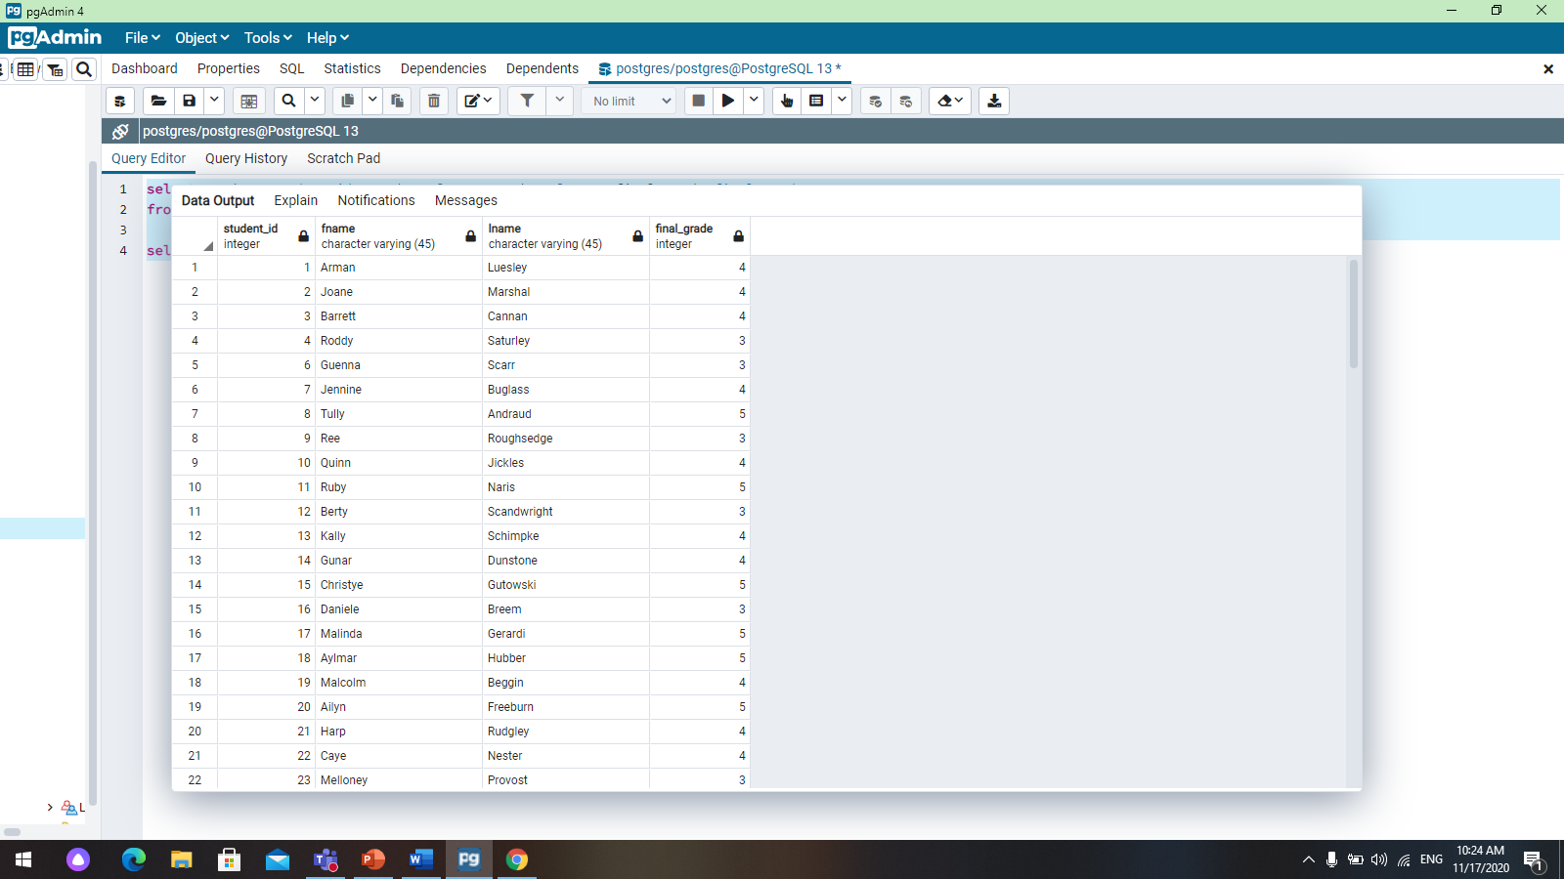

2. select student.student_id, student.fname, student.lname, final_grade.final_grade from student inner join grade on grade.grade_id=student.grade_id inner join final_grade on grade.final_id=final_grade.final_id where final_grade=5;

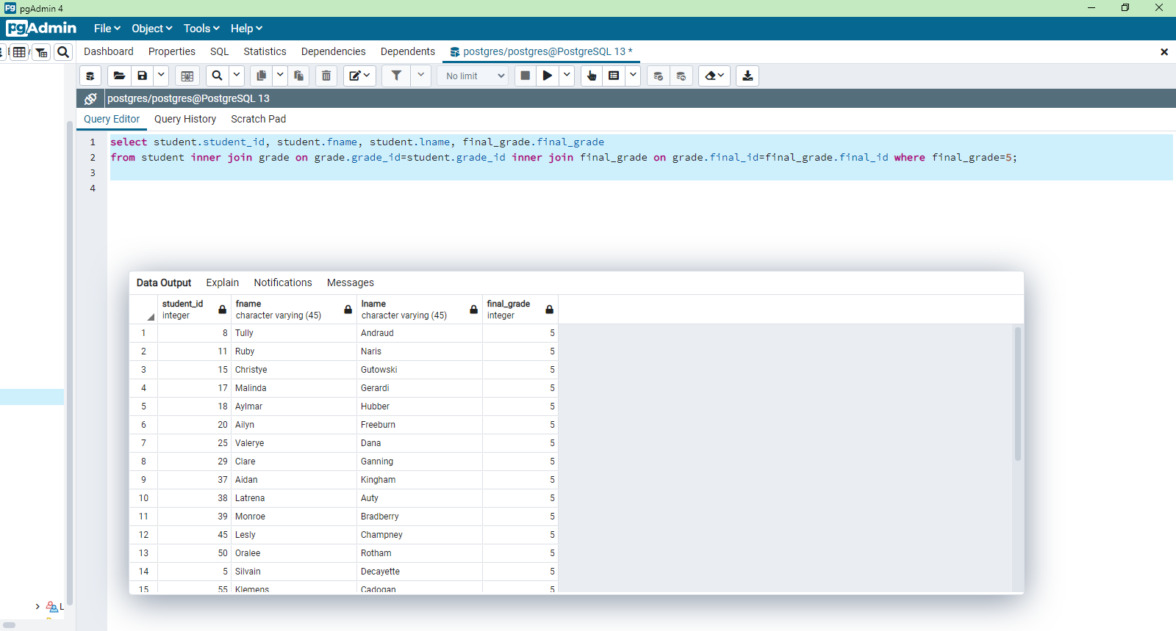

3. select count (attendance.description) from attendance inner join student on student.attendance_id=attendance.attendance_id where attendance.description='absent' group by attendance.description;

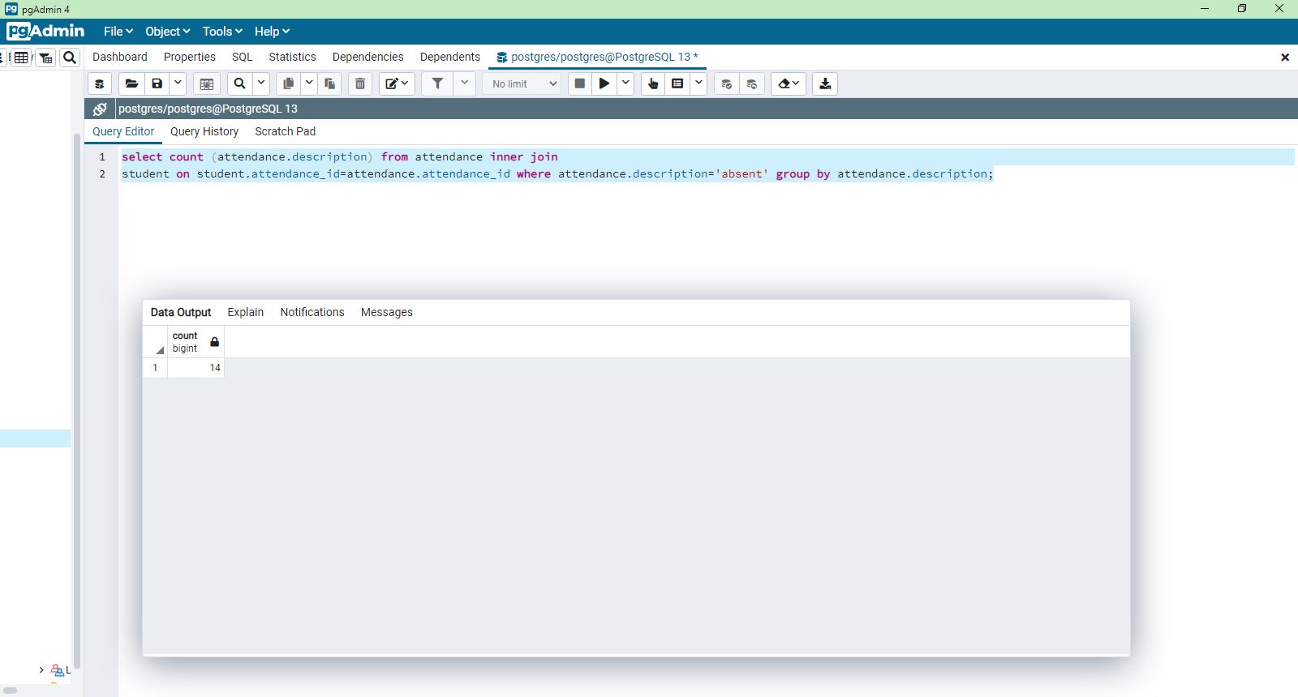

4. select student.student_id, student.fname, student.lname, parent.fname, parent.lname from parent inner join student on parent.parent_id=student.parent_id where student.date_birth between '2001-01-01' and '2002-12-31';

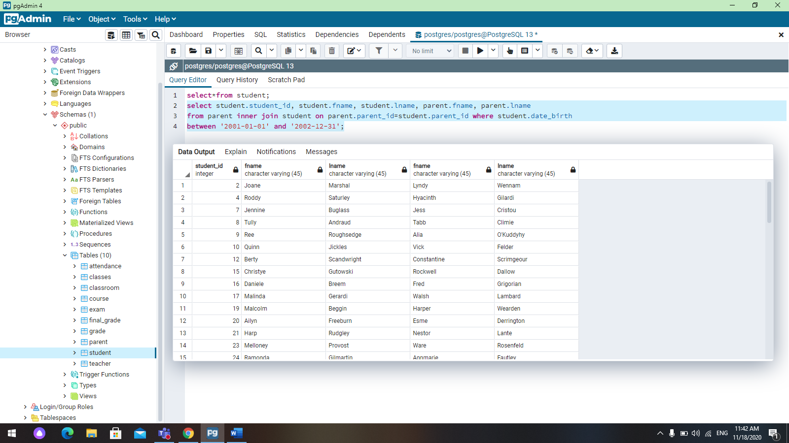

5. select student.student_id, student.fname, student.lname, exam.exam_name from exam left join student on exam.exam_id=student.exam_id where exam.description in ('variant 1');

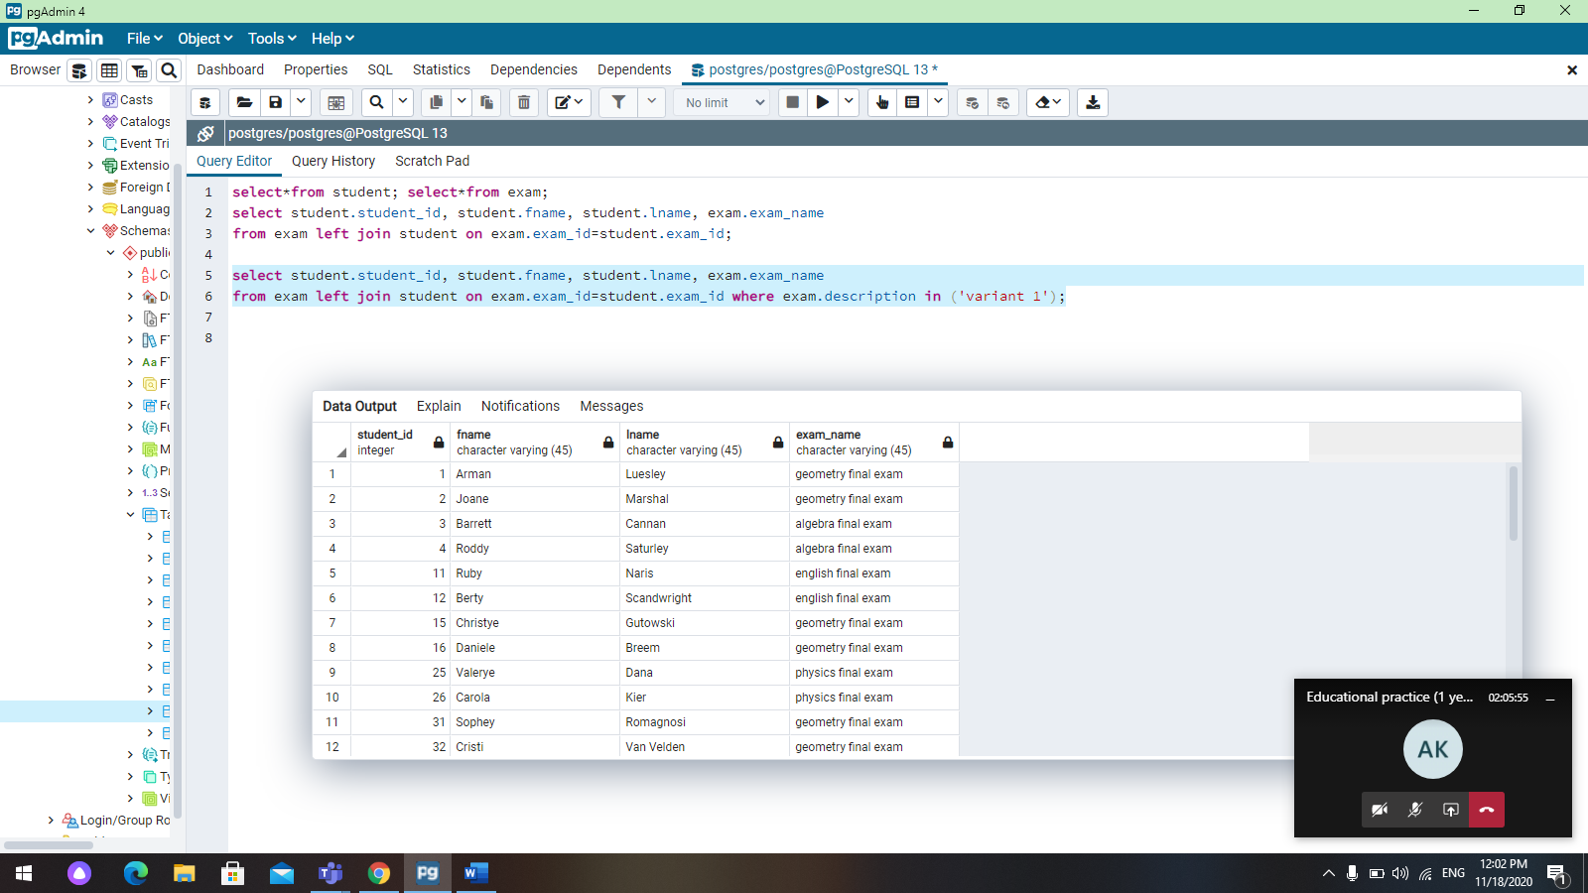

6.

select classes.class_name, teacher.fname, teacher.lname, teacher.course_id from classes right join teacher on teacher.teacher_id=classes.teacher_id;

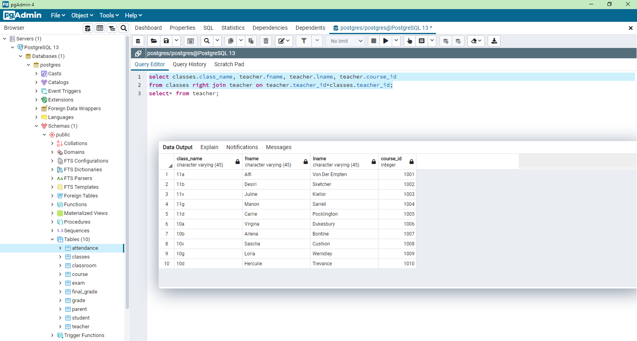

7.

select *from classroom full outer join classes on classes.classroom_id=classroom.classroom_id;

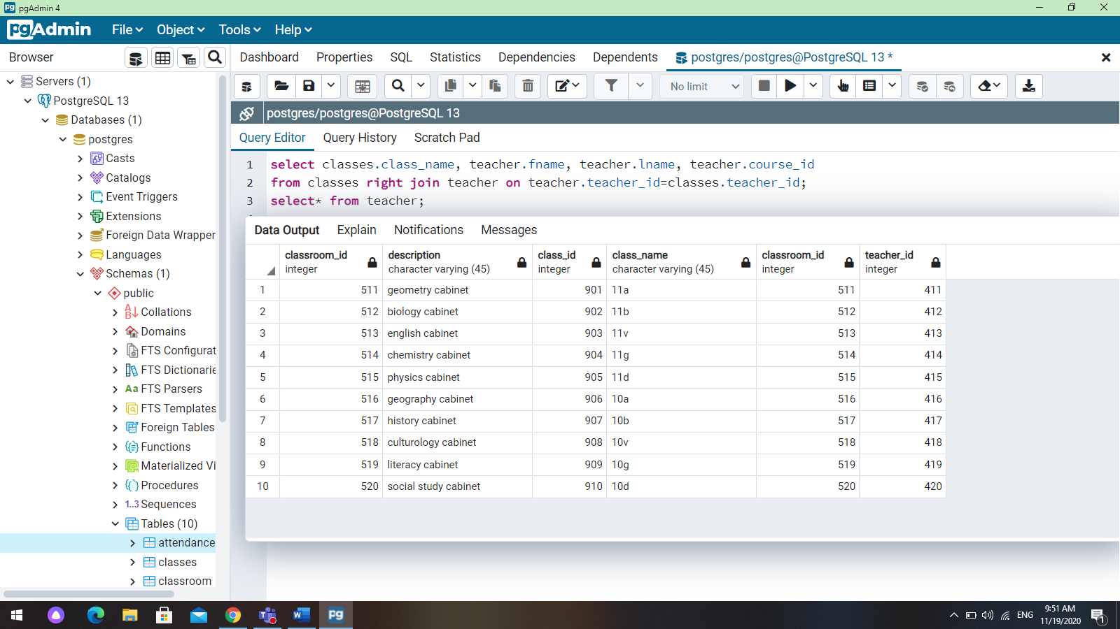

8.

select student.fname, student.lname, classes.class_name, teacher.fname, teacher.lname from student inner join classes on student.class_id=classes.class_id inner join teacher on classes.teacher_id=teacher.teacher_id where teacher.date_birth>'01-01-1985';

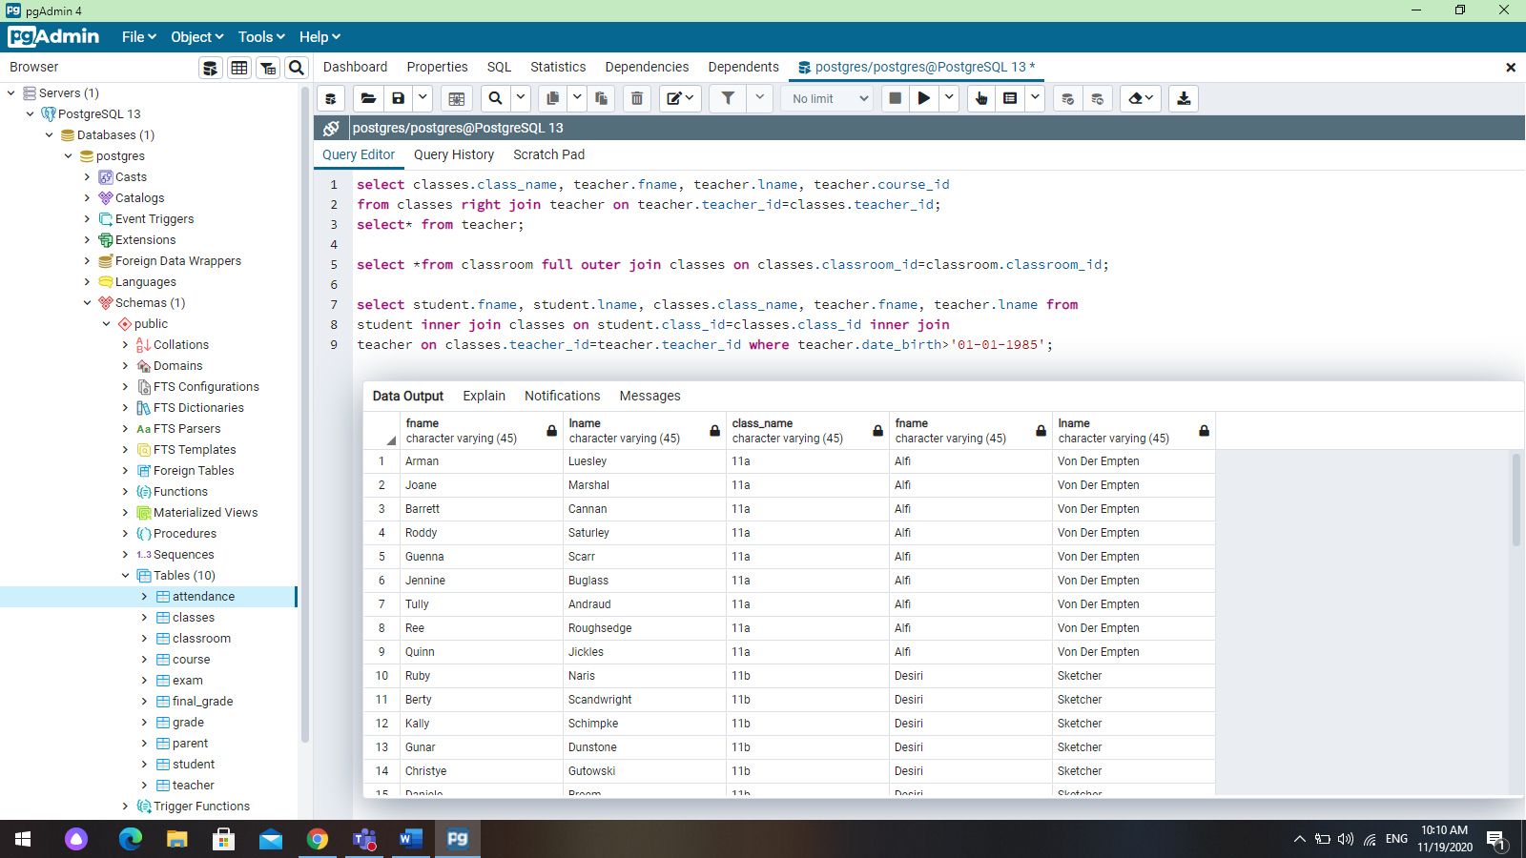

9.

select student.fname, student.lname, student.date_birth, parent.parent_id from parent right join student on parent.parent_id=student.parent_id where student.fname like 'A%';

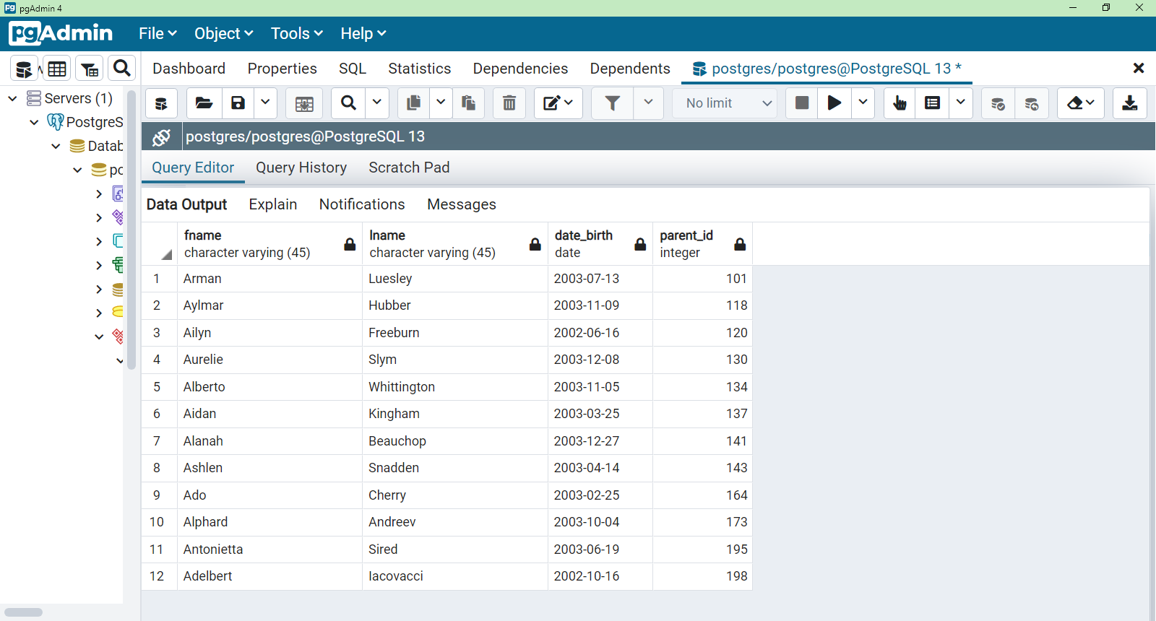

10.

select avg(final_grade) from final_grade where course_name='geometry';

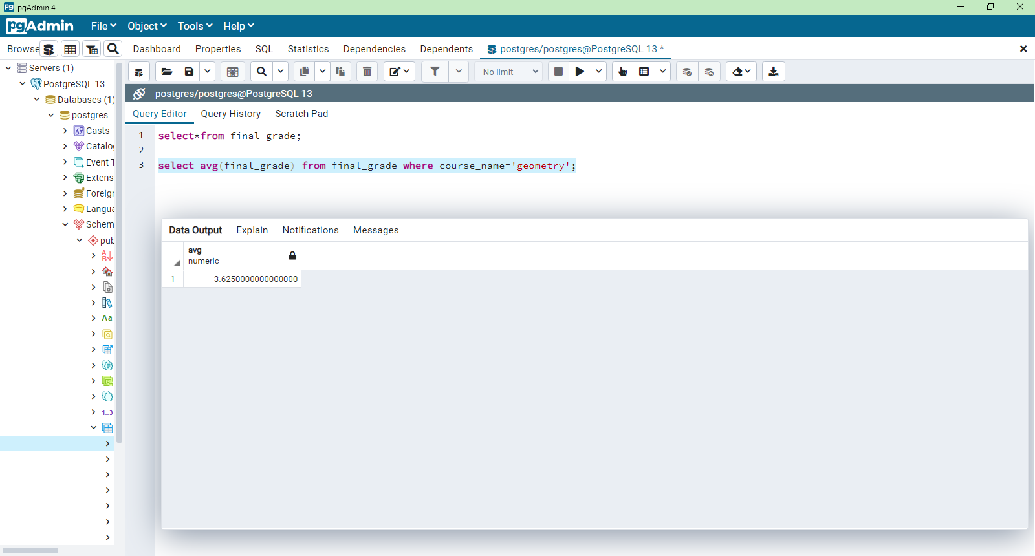

11. select student.fname, student.lname, teacher.teacher_id, course.course_name from student inner join classes on student.class_id=classes.class_id inner join teacher on classes.teacher_id=teacher.teacher_id inner join course on teacher.course_id=course.course_id;

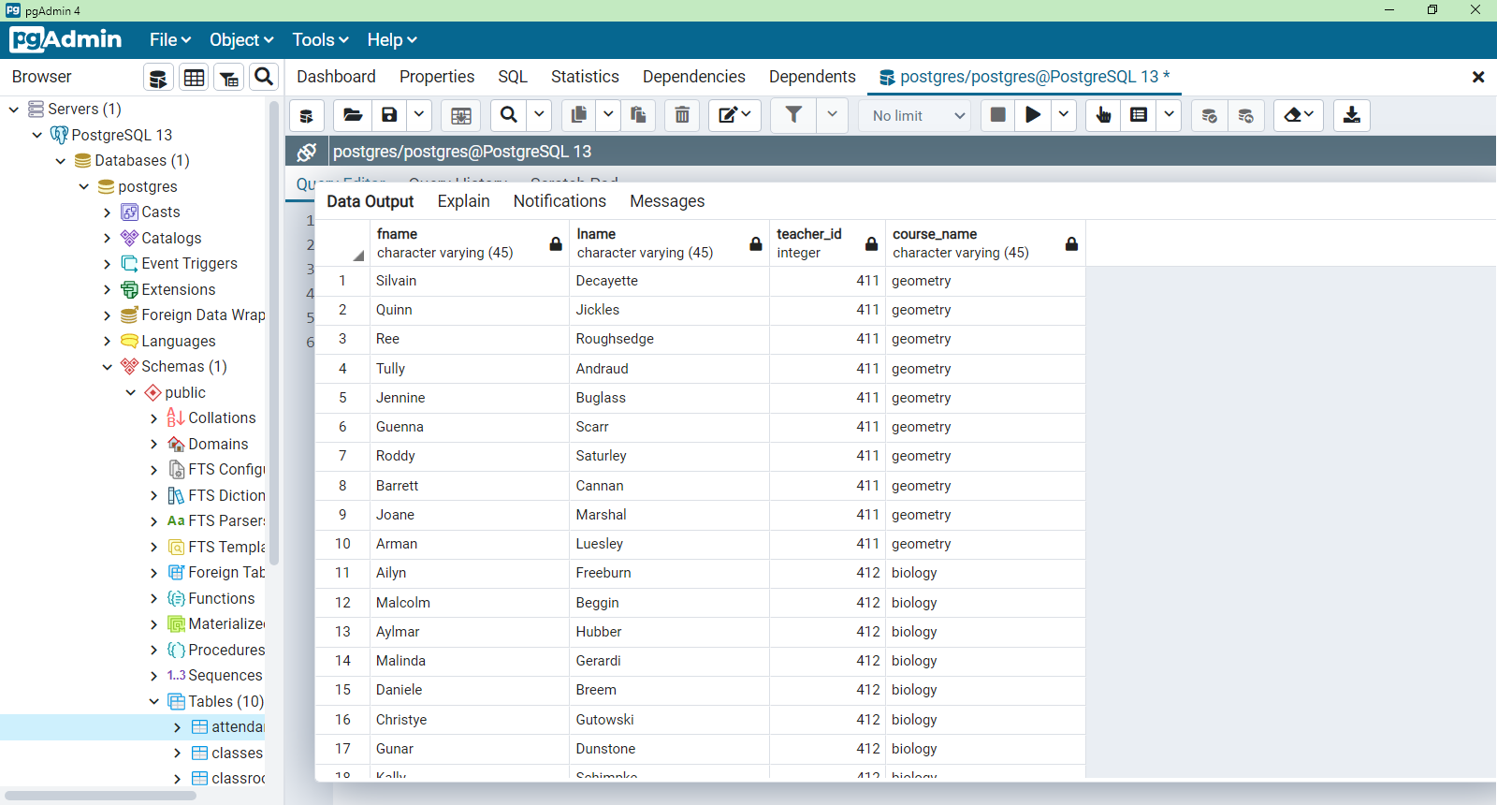

**7-task.**

1. select student.fname, student.lname, grade.grade_1 from student, grade where student.grade_id=grade.grade_id and grade_1>(select grade_1 from grade where grade_id=607 );

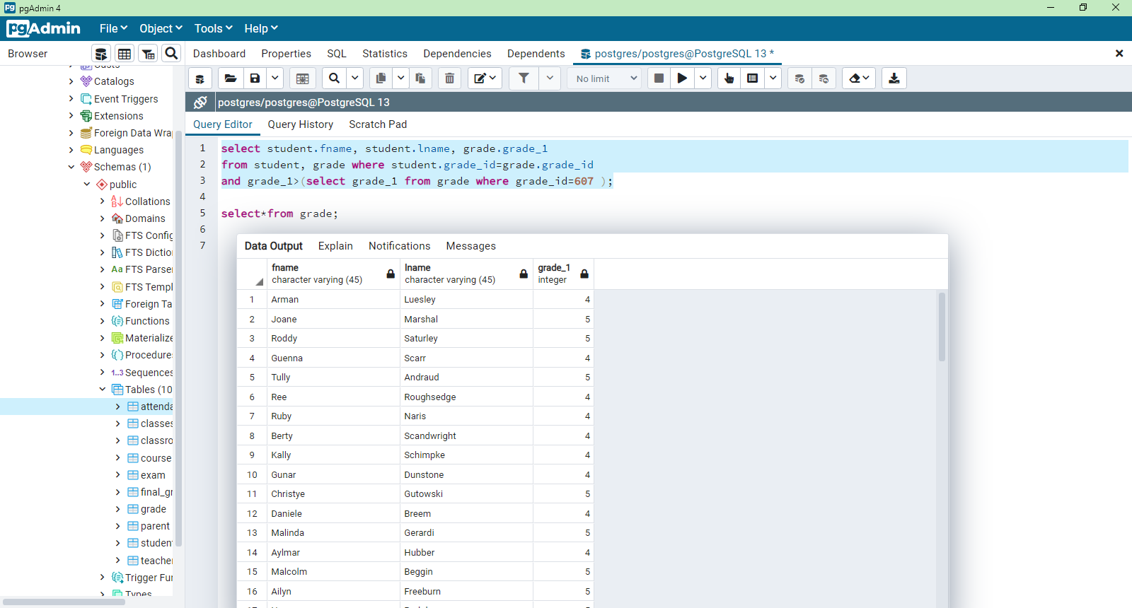

1. select student.fname, student.lname, attendance.date, attendance.description from student, attendance where student.attendance_id=attendance.attendance_id and description=(select description from attendance where attendance_id=312 );

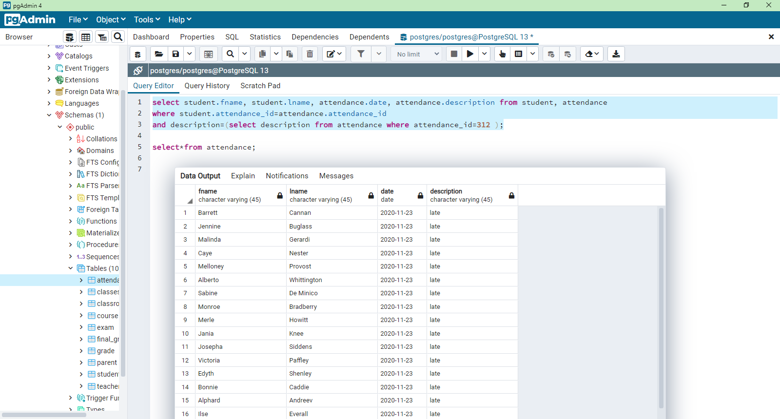

3. select grade_id, description, grade_1, grade_2, grade_3, grade_4, grade_5, final_id from grade where final_id IN (select final_id from final_grade where course_name='algebra' );

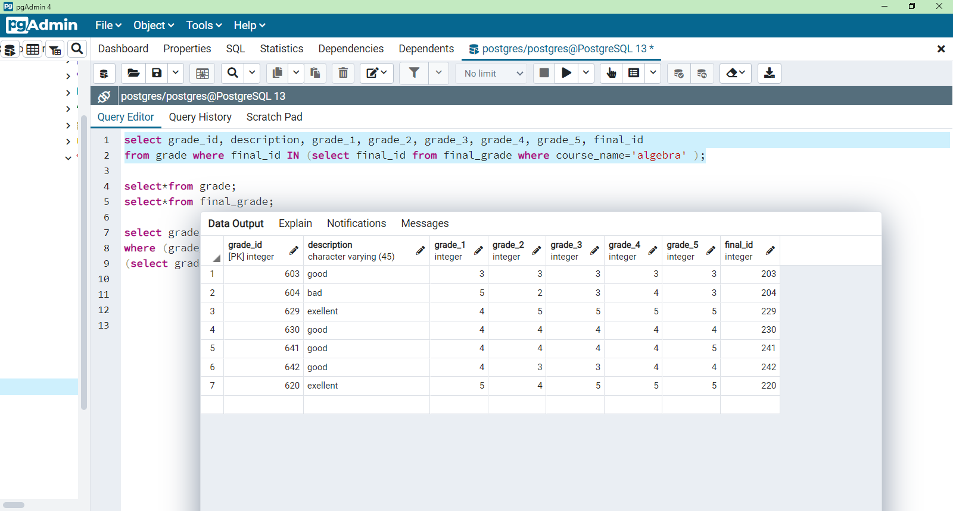

4. select student_id, fname, lname, grade_id, student_email from student where grade_id=any(select grade_id from grade where description='bad' );

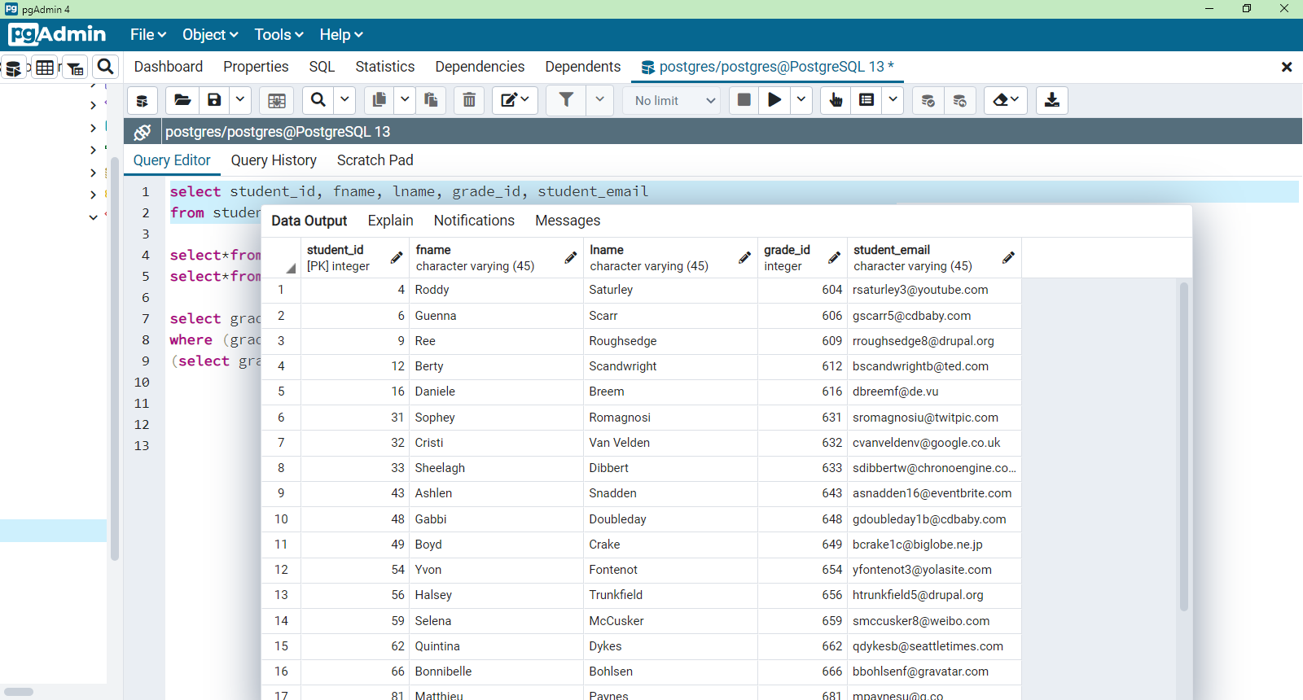

5.

select grade_id, description, grade_1, grade_2, grade_3, grade_4, grade_5, final_id from grade where final_id NOT IN (select final_id from final_grade where course_name='geometry' );

